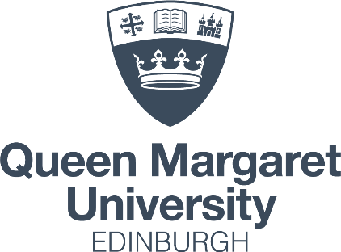
Division of Media, Communication and Performing Arts
Suggested Readings
Please remember these are suggestions – don’t worry if you cannot access everything on this list. We are offering these in case you want to get a head start, or even just want to brush up your knowledge over the summer. Don’t rush out and buy everything – most resources will be available in the Library or online.
BA(Hons) Drama

Here’s a list of resources you will use throughout your studies at QMU. Don’t worry if you can’t find or manage to read all these before September – this list isn’t meant to scare! However, if you can dip into at least a few of these, it will help you in your studies.
For students coming into 2nd year:
Aston, E., Savona, G. (1991) Semiotics of performance. Theatre as Sign System: a semiotics of text and performance (Routledge)
Bloom, H. (1999) The Western Canon: The Books and School of the Ages (London: Penguin).
Brook, P. (1968) The Empty Space. (London: Penguin).
Carlson, M. (2017) Performance: A Critical Introduction Paperback, 3rd edition (London: Routledge).
Fischer-Lichte, E. 2014. The Routledge Introduction to Theatre and Performance Studies. Routledge.
Fischer-Lichte, E. 2002. History of European Drama and Theatre. Routledge.
Kershaw, B. 1992. The Politics of Performance Radical Theatre as Cultural Intervention. Routledge.
Findlay, B (ed) 1996. A History of Scottish Theatre. Polygon.
Schechner, R. (2013) Performance Studies: An Introduction, 3rd edition (London: Routledge).

BA (Hons) Film & Media
Welcome to Film and Media at QMU. We're looking forward to getting to know you in September and hope your transition to University will be smooth and enjoyable.
If you're looking to do some preparatory work over the Summer, there are plenty of good books to help you get up to speed with the subject, but here are a few good online resources for you to have a look at:
- Film Studies for Free - https://filmstudiesforfree.blogspot.com/
- David Bordwell's Blog - http://www.davidbordwell.net/blog/
- Lindsay Ellis, Film Studies through the lens of Transformers - https://www.youtube.com/watch?v=PRXI__Wixas&list=PLJGOq3JclTH8J73o2Z4VMaSYZDNG3xeZ7
In the meantime, keep watching, making and thinking about media on your own, and we'll see you soon!
BA (Hons) Media & Communications

TBC

BA (Hons) PR & Marketing Communications

Hello and welcome to QMU. We are a small friendly team who are looking forward to meeting you virtually at the Coming from College induction session in July and then in person in September.
If you are studying PR and Marketing Communications, we have a busy and exciting year planned for you. If you would like to do a bit of pre-reading over the summer then a good place to start and texts you may already be familiar with are:
- TENCH, R. & YEOMANS, L., eds. 2017. Exploring Public Relations. Harlow: Pearson.
- THEAKER, A., ed. 2016. Public Relations Handbook. London: Routledge
Earlier versions are also available and fine too and you may also be able to access the e-books.

