School/Department/Unit: | Work activity:
Assessment completed by: | Date completed: | Review Period:

This is a Generic Risk Assessment for… (please summarise the activity/event).

Who might be harmed – Staff, students, and visitors.

Risk Score Matrix (5x5) |  |  |  |  |  |  | Risk Score and Description
Likelihood |  | Severity |  |  |  |  | Risk Score | Risk Level | Category | Description
 |  | Insignificant | Minor | Moderate | Major | Fatal
 | Very Unlikely | 1 | 2 | 3 | 4 | 5 | 1-4 | Low | Acceptable | No further actions needed
 | Unlikely | 2 | 4 | 6 | 8 | 10 | 5-9 | Medium | Tolerable/Acceptable | Should be reviewed to ensure that there is nothing else which could be done.
 | Possible | 3 | 6 | 9 | 12 | 15 | 10-15 | High | Undesirable | Immediately review current control measures, and where appropriate, decide on further actions.
 | Likely | 4 | 8 | 12 | 16 | 20 | 16-25 | Very High | Unacceptable | Stop activity immediately and make urgent improvements.
 | Almost Certain | 5 | 10 | 15 | 20 | 25 | Likelihood (L) x Severity (S) = Risk Score (RS)

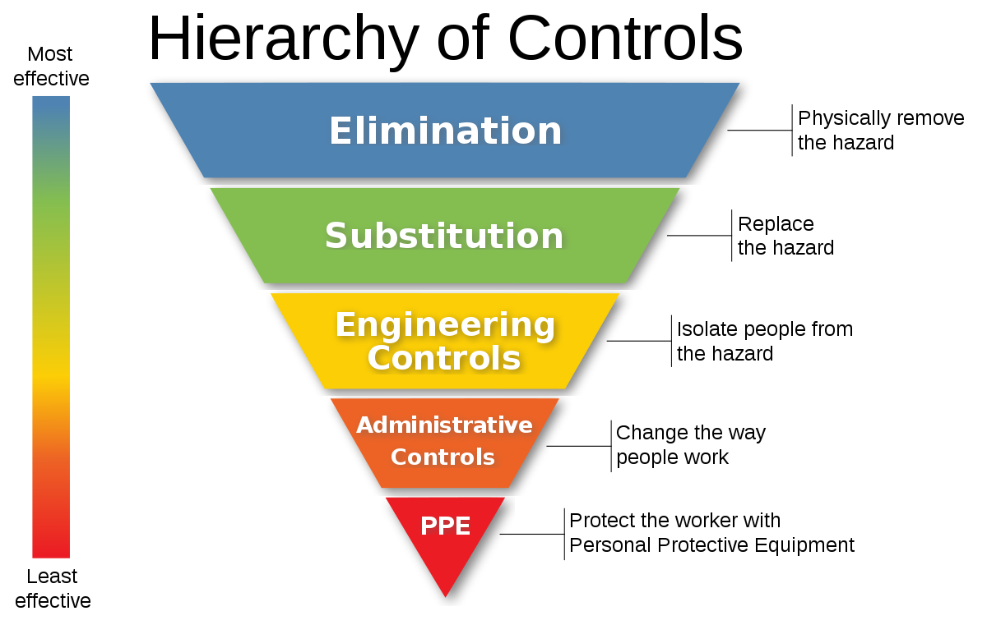

Reference | Risk Area | Severity (1-5) | Likelihood (1-5) | Initial Risk Level | Existing Control Measures  (What are you already doing?) | What further action is necessary | Severity (1-5) | Likelihood (1-5) | Final Risk Level

