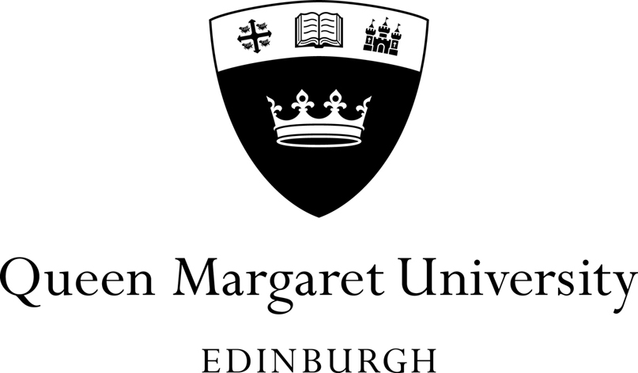

Annual High Level Statement on Compliance with the Concordat for Research Integrity 2017

- Background

The Concordat to Support Research Integrity was published in July 2012 by Universities UK. A Progress Report published in November 2016 confirmed that the Concordat approach continues to be favoured over alternatives such as direct regulation. The Joint UK Funding Councils have included compliance with the Concordat as a condition of grant and it is a requirement for receipt of RCUK funding.

The Concordat recommends that institutions should make an annual statement on research integrity which is made publicly available. In accordance with this recommendation this annual statement provides details of activities undertaken to enhance research integrity within the University.

The Concordat helps to ensure that research produced or in collaboration with the UK research community is underpinned by the highest standards of rigour and integrity. The Concordat outlines five commitments that those engaged in research can make to help ensure that the highest standards of integrity are maintained. These are:
- Maintaining the highest standards of rigour and integrity in all aspects of research.
- Ensuring that research is conducted according to appropriate ethical, legal and professional frameworks, obligations and standards.
- Supporting a research environment that is underpinned by a culture of integrity and based on good governance, best practice and support for the development of researchers.
- Using transparent, robust and fair processes to deal with allegations of research misconduct should they arise.
- Working together to strengthen the integrity of research and to reviewing progress regularly and openly.
QMU complies fully with the five commitments set out in the Universities UK Concordat to support research integrity.
- Annual High Level Statement 2017

Any formal investigations of research misconduct that have been undertaken in 2017

- There have been no formal investigations of research misconduct by a research student or a member of staff during 2017.
Activities undertaken to enhance research integrity within the University.

- Implementation of new governance structures through the introduction of a new annual review of process for Research Centres.
- Annual Review of the Graduate School.
- Development and issue of new QMU guidance around Disclosure Scotland and Protection of Vulnerable Groups (PVG) checks.
- Development and launch of a new and enhanced website to promote good practice.
- Incorporation of aspects of research integrity into academic mentoring.
- Development of a University-wide communications plan for launch in early 2018.
- Higher visibility of the Concordat to Support Research Integrity on committee agendas including School Research and KE Strategy Groups.
Ongoing Review and Oversight

QMU will continue to develop and identify mechanisms to allow oversight and inspection of key activities supporting research integrity to support researchers and identify good practice. This will feed into existing processes and may involve:

- Funding application procedures.
- Auditing of specific studies and/or processes.
- Self-assessment by researchers.
- Peer group consideration of challenging or novel research areas.
- Mentorship programmes.
- Awareness scoping exercise.
- Research Integrity and commercial research - SME and industry engagement.

