

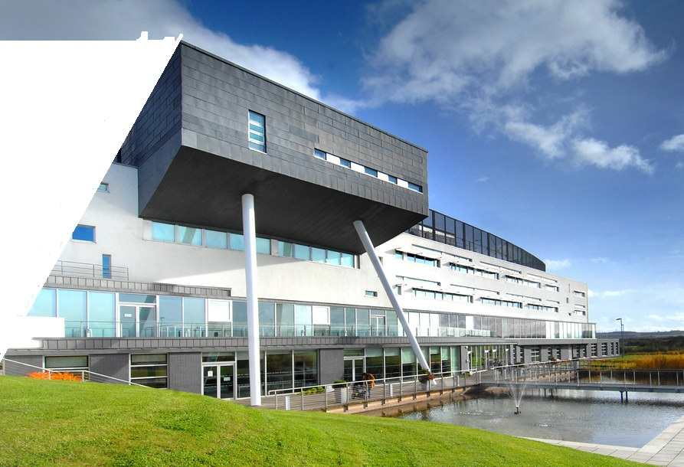

WELCOME 2
Introduction to the programme 3
Why QMU 3
What our students say about us 4
HOW YOUR PROGRAMME WORKS 5
Standard full and part time routes 6
PG Diploma, Certificate and other pathways 7
Teaching timetable 2020/21 8
Semester 1 8
Semester 2 10
MORE ON YOUR PROGRAMME 13
Meet the team 13
Communicating with us 15
Assessments 16
OTHER INFORMATION 18
What to do first 18
Sources of information and help 19
Join the QMU community 21

WELCOME

Welcome to the taught Masters programme in Strategic Communication and Public

Relations at Queen Margaret University (QMU). We hope that the course is a success for you and that studying with QMU proves to be a valuable and enjoyable experience.

The purpose of this handbook is to give you some information about the course. Its aims, content, and structure are explained in detail. Information about the School of Arts, Social Sciences and Management, the Media, Communications and Performing Arts Division, the running of the course, and student support is also provided. Some regulations and procedures are outlined too.
WELCOME

WELCOME


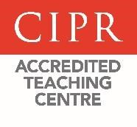

HOW YOUR PROGRAMME WORKS
There are a number of potential routes that students are likely to take through the programme, specifically these are:

- Full-time September start
- Full-time January start
- Part-time September start
- Part-time January start
- PG Certificate in Strategic Communication and Public Relations
- PG Diploma in Strategic Communication and Public Relations
- Agreed pathways

Each module you study earns you a certain amount of credits (in multiples of 20). To gain the award of MSc you must gain 180 credits, a Postgraduate Diploma (PGDip) is 120 credits and a Postgraduate Certificate (PGCert) is 60 credits. Students will be expected to complete with the maximum periods of registration set by QMU. These are:
Programme |  | Maximum period for completion | Minimum period for completion
Masters | FT | 4 calendar years | 1 calendar year
Masters | NFT | 7 calendar years | 2 ½ calendar years
PgDip | FT | 3 calendar years | 1 calendar year
PgDip | NFT | 5 calendar years | 2 calendar years
PGCert | FT | 2 calendar years | 1 semester
PGCert | NFT | 4 calendar years | 1 calendar year

HOW YOUR PROGRAMME WORKS
To gain an MSc Strategic Communication and Public Relations award you need to obtain 180 credits. Full-time students will normally complete the programme within either 12 months (Sept start) or 18 months (January start).

Full-time Jan start students would begin with the semester 2 modules, then semester 1 before moving on to their final project in Jan to April of the following year.

Part-time students may start in either September or January and may take three 20 credit modules in each academic year.

Semester 1 | Semester 2 | Semester 3
IM194 Media Theory and Campaigning | IM218 Digital Communications | IM201 Masters  Communication  Project  OR  IM200 Masters  Communication  Dissertation
IM197 Strategic  Communication Planning and Digital Practice | IM198 Public Affairs
TM186 Designing  Qualitative Research (if Research Methods (online)  not taken in semester 2)  OR  IM219 Industry-based Learning and Professional Development  OR  Option (from a selection from ASSAM optional  module list) | BM104 Research Methods  (online) (if 20 credit  Designing Qualitative Research not taken in semester 1)  OR  IM219 Industry-based Learning and Professional Development  OR  Option (from a selection  from ASSAM optional module list)

HOW YOUR PROGRAMME WORKS
To gain a PGDip in Strategic Communication and Public Relations, students must gain 120 credits in the following modules:

Semester 1 | Semester 2
IM194 Media Theory and Campaigning | IM218 Digital Communications
IM197 Strategic Communication Planning and Digital Practice | IM198 Public Affairs
TM186 Designing Qualitative  Research (if Research Methods  (online) not taken in semester 2)  OR  IM219 Industry-based Learning and Professional Development  OR  Option (from a selection from  ASSAM optional module list) | BM104 Research Methods (online)  (if 20 credit Designing Qualitative  Research not taken in semester 1)  OR  IM219 Industry-based Learning and Professional Development  OR  Option (from a selection from  ASSAM optional module list)

To gain a PGCert in Strategic Communication and Public Relations, students must gain 60 credits in three of the following modules:
Semester 1 | Semester 2
IM194 Media Theory and Campaigning | IM218 Digital Communications
IM197 Strategic Communication Planning and Digital Practice | IM198 Public Affairs

Details of routes through the programme if you are joining on an agreed pathway or have done one of the CIPR Diploma courses are available from the Programme Leader. E-mail icasteltrione@qmu.ac.uk
HOW YOUR PROGRAMME WORKS

CORE modules taught face-to-face are delivered in short intensive teaching blocks on Fridays or Saturdays, as per timetable below. Please be aware there may be changes to this and you should check it against your QMU online timetable.

Details of optional modules are available from your Programme Leader and the School Office. If you have not received these please e-mail icasteltrione@qmu.ac.uk or SchoolOffice@qmu.ac.uk

Full time MSc students attend all classes for their CORE modules plus those for their two chosen options. Their options may include: Designing Qualitative Research if Research Methods (online) is not taken in semester 2; or another option from ASSAM optional module list; or Industry-based Learning and Professional Development.

Students should attend Industry-based Learning and Professional Development preparation workshops if they have selected this option and want to pursue a 150-hours placement or other industry-based activities during semester 2 or 3.

For the timetable and mode of delivery of the optional modules you are interested in please contact your Programme Leader, icasteltrione@qmu.ac.uk.

Draft Semester 1 Timetable
Note that the timetable included below is a draft and subject to changes. The final timetable will be published in August.

QMU week | w/c | Friday | Saturday
1 | 6 September
2 | 13 September | Induction
3 | 20 September | CORE: IM194 Media Theory and Campaigning  (13.15-16.15) | CORE: IM197 Strategic Communication and Digital Practice  (10.00-13:00)
4 | 27 September | OPTION: IM219 Industry-based Learning and Professional Development  (10.15-13.15)
5 | 4 October 2021 | CORE: IM194 Media Theory and Campaigning  (13.15-16.15) | CORE: IM197 Strategic Communication and Digital Practice  (10.00-13:00)
6 | 11 October | CORE: IM200/201 MSc Dissertation/ Project workshop (prep for submission in April)  (13.15-16.15)
7 | 18 October | CORE: IM194 Media Theory and Campaigning  (13.15-16.15) | CORE: IM197 Strategic Communication and Digital Practice  (10.00-13:00)
8 | 25 October | Reading Week
9 | 1 November | CORE: IM194 Media Theory and Campaigning  (13.15-16.15) | CORE: IM197 Strategic Communication and Digital Practice  (10.00-13:00)
10 | 8 November | CORE: IM197 Strategic Communication and Digital Practice  (10.00-13:00)
11 | 15 November | CORE: IM194 Media Theory and Campaigning  (13.15-16.15) | CORE: IM197 Strategic Communication and Digital Practice  (9.15-15.15)
12 | 22 November | OPTION: IM219 Industry-based Learning and Professional Development  (10.15-13.15)  CORE: IM200/201 MSc Dissertation/ Project workshop (prep for submission in April)  (13.15-16.15)
13 | 29 November
14 | 6 December
15 | 13 December

HOW YOUR PROGRAMME WORKS
Full time MSc students attend all classes for their CORE modules plus IM200 MSc Dissertation or IM201 Project preparation workshops – depending on their choice – and one option that may include: Industry-based Learning and Professional Development; or Research Methods (online) if Designing Qualitative Research was not taken in semester 1; or another option from ASSAM optional module list.

Students should attend Industry-based Learning and Professional Development preparation workshops if they have selected this option and want to pursue a 150-hours placement or other industry-based activities during semester 3 or 1 in the next academic year.
Draft Semester 2 Timetable
Note that the timetable included below is a draft and subject to changes. The final timetable will be published in August.

HOW YOUR PROGRAMME WORKS
QMU week | w/c | Friday | Saturday
19 | 10 January | Induction
20 | 17 January | CORE: IM218 Digital Communications  (14.15-17.15)
21 | 24 January | CORE: IM198 Public Affairs  (10.15-13.15)  CORE: IM218 Digital Communications  (14.15-17.15) | OPTION: IM219 Industry-based Learning and Professional Development  (10.00-13.00)
22 | 31 January | CORE: IM218 Digital Communications  (14.15-17.15)
23 | 7 February 2022 | CORE: IM198 Public Affairs  (10.15-13.15)  CORE: IM218 Digital Communications  (14.15-17.15)
24 | 14 February | CORE: IM200/201 MSc Dissertation/ Project workshop (prep for submission in August)  (10.15-13.15)  CORE: IM218 Digital Communications  (14.15-17.15)
25 | 21 February | CORE: IM198 Public Affairs  (10.15-13.15)  CORE: IM218 Digital Communications  (14.15-17.15) | OPTION: IM219 Industry-based Learning and Professional Development  (10.00-13.00)
26 | 28 February | Reading Week
27 | 7 March 2022 | CORE: IM198 Public Affairs  (10.15-13.15)  CORE: IM218 Digital Communications  (14.15-17.15)
28 | 14 March | CORE: IM218 Digital Communications  (14.15-17.15)
29 | 21 March | CORE: IM198 Public Affairs  (10.15-13.15)  OPTION: IM219 Industry-based Learning and Professional Development  (13.15-16.15)
30 | 28 March | CORE: IM200/201 MSc Dissertation/ Project workshop (prep for submission in August)  (14.15-17.15)
31 | 4 April 2022
32 | 11 April
33 | 18 April

Meet the team

Profiles of staff in the Division of Media, Communication and Performing Arts can be found at https://www.qmu.ac.uk/schools-and-divisions/mcpa/mcpa-staff/. It's a good idea to look us up and find out about our areas of research and practice.

Head of Division:  John Dean  E-mail: jdean@qmu.ac.uk  Associate Head of Division:  Dr Lesley-Ann Dickson  E-mail: ldickson@qmu.ac.uk | John Dean and Dr Lesley-Ann Dickson are respectively Head and Associate Head of the Media, Communication and Performing Arts Division at QMU. The MSC Strategic Communication and  Public Relations sits within this Division.

MORE ON YOUR PROGRAMME

Dr Magda Pieczka  E-mail: mpieczka@qmu.ac.uk  Magda is the module co-ordinator for IM194  Media Theory and Campaigning and IM198  Public Affairs and supervises Dissertations/Projects. She also leads the CIPR Specialist Diploma (Public Affairs) at QMU. | 
Ann Turner  E-mail: aturner@qmu.ac.uk  Ann leads the undergraduate PR programmes at QMU. On the MSc Strategic Communication and Public Relations she teaches on IM194 Media Theory and Campaigning and supervises Dissertations/Projects. | 
Emma Wood  E-mail: ewood@qmu.ac.uk  Emma is the module coordinator for IM197 Strategic Communication and Digital Practice, teaches on IM218 Digital Communications, and supervises Dissertations/Projects. Emma also leads the CIPR Professional Diploma and CIPR Specialist Diploma (Digital Communications) at QMU. | 

MORE ON YOUR PROGRAMME
The School Office

E-mail: SchoolOffice@qmu.ac.uk

The School Office provides administrative support to the MSc Strategic Communication and Public Relations programme. E-mail the School Office with any queries about administrative procedures (including applications for extensions), submitting assessments, and preparation of marks for the Exam Board and issue of marks.

Please visit the School Office to find out where it is and familiarise yourself with their procedures. It is located to the left of the main entrance on level 1.

The best way to communicate with us is face to face during teaching sessions - it's always good to get feedback and participation (even if it's to tell us you don't understand something!).

Otherwise, we all use e-mail. Please ensure that you use your QMU e-mail account, review it regularly and clear your inbox frequently, so that it can always accept mail. We will not, for data protection reasons, communicate with you via your own personal e-mail addresses.

Our e-mail addresses are in the Meet the team section. And remember that we will often e-mail you from our module Hub areas with information about teaching. Please note that as some of us work part time we may not be available every day of the week.

We also have formal communication structures and you will elect two class representatives to take part in staff student consultative and programme committees (held once a semester). We like to involve as many students as possible in our SSCC meetings, and also give all students the opportunity to provide feedback on all modules (to inform future planning and development).

And, of course you get individual supervision for your dissertation or final project which gives you an opportunity to develop closer links with tutors who share your interests.
MORE ON YOUR PROGRAMME

Assessments

Assessment approaches for our core modules are:
Module | Credits |  | Assessment |  | Module Coordinator
Semester 1
IM194 Media Theory and Campaigning | 20 |  | 2,500 words Case Study: Media Campaign Analysis (50%) + 2,500 words Essay (50%) |  | Dr Magda Pieczka
IM197 Strategic  Communication and  Digital Practice | 20 |  | Campaign Plan (100%): 3,000 words Strategic Communication Proposal + Campaign Materials + 1,500 words Theoretical and Conceptual rationale underpinning the decisions |  | Emma Wood
Semester 2
IM218 Digital  Communications | 20 |  | Report (100%): 3,000 words Case Study Analysis and Digital Communications Strategy + 2,000 words Critical Evaluation. |  | Dr Isidoropaolo Casteltrione
IM198 Public Affairs | 20 |  | 2,000 words Case Study Analysis Report (40%) + 1,500 words Policy Brief (30%) + 1,500 words Essay: Occupational Issues/Theory (30%) |  | Dr Magda Pieczka
Semester 3
IM201 Masters  Communication Project | 60 |  | Communication Project (100%): 3,000 words Critical Literature Review + Production of Communication Materials +  2,000 words Critical Reflection |  | Emma Wood
 | OR
IM200 Masters  Communication  Dissertation | 60 |  | 12,000 words Dissertation (100%) |  | Dr Isidoropaolo Casteltrione

MORE ON YOUR PROGRAMME
Your assessment specifications and marking criteria will be made available on the individual module Hub areas. If you are not sure about the marking criteria that will be used when marking your work or how to interpret them, ask the coordinator for that module.

Key points relevant to assessment at postgraduate level are:
- The pass mark is 50%
- To pass a module, a student must also achieve a mark of not less than 40% in each of the assessment components
- The maximum mark awarded at resit is 50%
- A student will normally be required to withdraw from a postgraduate award if he or she accumulate four or more fails, whether or not these have been later redeemed through reassessment, on any standard taught modules.
- To be eligible for distinction, the weighted average of a student's marks must be greater than or equal to 70%. To be eligible for merit, it must be greater than or equal to 60%.

QMU’s assessment regulations and grade descriptors guiding our marking can be found here: https://www.qmu.ac.uk/media/4038/assessment-regulations-2017-final.pdf

Our academic appeals procedure is here: https://www.qmu.ac.uk/media/3961/academicappeals.pdf

Exam Boards are held three times a year:
- June to confirm semester 1 and 2 marks
- August to confirm reassessment marks
- September to confirm Dissertation and Project marks and make Masters awards
QMU’s graduation ceremony is held once a year in July.
OTHER INFORMATION

Attending all the induction sessions is really important. At these you'll be introduced to all our systems as well as being shown how to access the library and online teaching resources. You'll also meet your course leaders, lecturers and fellow students. Access the Induction programme here: https://www.qmu.ac.uk/current-students/current-students-general-information/induction-for-new-stud ents/induction-programme-list-september/strategic-communication-and-pr-induction-programme/
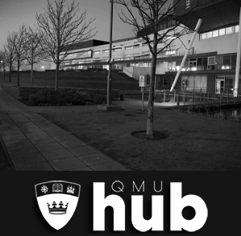
We all use an online teaching system called ‘The Hub’ to store teaching materials and to communicate with you. It's accessed via the QMU website or https://hub.qmu.ac.uk/. There you will see Hub sites for all your modules as well as for the PR Programmes area.

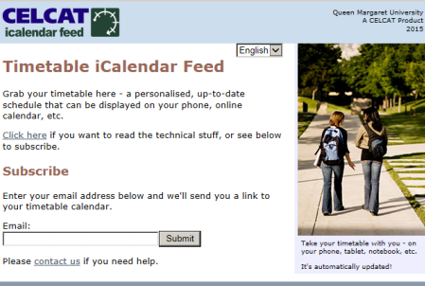
Some students find it difficult to navigate their timetable, especially as there can be last minute changes, so it's really important that you get used to accessing it regularly (and download the timetable app if possible) https://www.qmu.ac.uk/current-students/current-students-general-information/timetables/.

In addition to this Handbook you will have access to: Hub areas for each of your modules where you can find guides for each of the modules detailing teaching and assessment; and a PR Programmes Hub area where you can find non-module specific content.

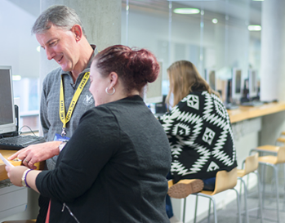
Effective Learning Service (ELS)
Throughout the year, our ELS offer a series of academic workshops - it's a good idea to go to these. The ELS also has handouts which are invaluable - their door is always open and you should drop in https://www.qmu.ac.uk/study-here/student-services/effective-learning-service-els/ .

OTHER INFORMATION

The Learning Resource Centre (LRC)

The LRC is a key resource for staff, students and researchers. The LRC offers a variety of services including Library workshops, subject support, additional help for disabled users, and specialised research support – see here: https://www.qmu.ac.uk/study-here/learning-facilities/library/

OTHER INFORMATION


Personal Academic Tutor (PAT)
Each student is allocated a PAT. This is a member of the departmental staff operating the degree. Their role it is to provide academic guidance and support. PATs periodically review your progress through the programme, giving advice and assistance with any difficulties that arise in connection with your studies. Information on your PAT will be available on the Student Portal. Find more at: https://www.qmu.ac.uk/media/4005/pat-student-leaflet.pdf

More information and support
- Student Services https://www.qmu.ac.uk/study-here/student-services/
- Access (or print) our QMU Write and Cite guide https://libguides.qmu.ac.uk/referencing it's absolutely essential for ensuring that you use appropriate citation practice in your work.
- Support with your writing from our Royal Literary Fellows https://www.qmu.ac.uk/schools-and-divisions/mcpa/royal-literary-fund/
- If you have a disability (including individual learning plans) https://www.qmu.ac.uk/study-here/student-services/disability-service/
- If you are an International student https://www.qmu.ac.uk/study-here/international-students/

OTHER INFORMATION

There are many ways for you to become involved in your programme and in life at QMU in general. We want you to have the best experience while you are here with us so please take advantage of all the opportunities on offer. We love students getting involved in our own campaigns and interests - and we also love to help advance our students' campaigns. But, as well as all the opportunities offered on your modules, there’s lots of other ways to get involved in the QMU student community.

Student union, groups and societies
Check out all the activities at the QMU Student’s Union https://www.qmusu.org.uk/ , and our range of student clubs and societies here https://www.qmusu.org.uk/groups



OTHER INFORMATION
Become a class representative
Class representatives are elected at the beginning of the academic year and receive training on their role from the Students Union. As well as helping your classmates, the tutors and QMU, being a class rep looks great on your CV. If you’d like to know more ask Paolo Casteltrione, icasteltrione@qmu.ac.uk

The Staff Student Consultative Committee (SSCC)
The Staff Student Consultative Committee (SSCC) provides a forum for constructive discussion of the programme, the students’ experience of the programme and of possible programme developments. Class representatives are elected at the beginning of the academic year and receive training from the Students Union. Meetings are held once a semester.

Professional organisations
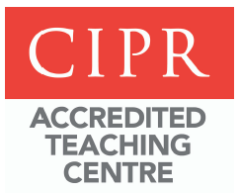
As a QMU student, you are eligible to join the Chartered Institute of Public Relations (CIPR) and the Public Relations Consultants Association (PRCA) both of which hold a number of social and professional activities throughout the year. Ask your Programme Leader for more information.

