



Welcome to Queen Margaret University.

You join us at an unusual and challenging time as we all adapt to new ways of living and working because of the COVID-19 outbreak.

When I joined Queen Margaret myself back in October, the University’s great community spirit was abundantly clear to me. In these testing times, that spirit is stronger than ever. While it is inevitable that our current circumstances will make it more challenging than usual for you to settle into your new role and get to know your new colleagues, I think you too will be impressed by the community spirit, and benefit from it.

At the current time, the information on our website and intranet is all the more important than ever. I’d draw your attention in particular to the QMU@Home section of the website. QMU@Home supports staff by bringing together useful resources related to working from home, including maintaining a good work/life balance, health and wellbeing advice, and ways of staying in touch with the QMU community during this uncertain time. The site also provides details of key contacts if you need specific support from colleagues.

You might also find the staff profiles by Division on the website helpful.

Your colleagues throughout the University are here to support you as you settle in, and are all available by email, wherever they are working. Please don’t hesitate to call on them. They will want you to succeed in your role.

I wish you every happiness and fulfilment in your time at Queen Margaret University, and I hope to have the opportunity to meet you in person when we return to work on campus.


Sir Paul Grice
Principal and Vice Chancellor

Your Induction
Plan @Home
Employee Name:
Job Title:
Division/Team:
Line Manager:
Employee’s Start Date:

Welcome to Queen Margaret University, this is Your Induction Plan @Home that will be designed by you and your line manager to enable you to carry out your role effectively and integrate you into the QMU community. Your Induction Plan @Home will run for the duration of your probationary period and it will be the responsibility of you and your line manager to ensure that you have successfully completed the Plan within this timescale. Your line manager will meet with you on a regular basis to help you integrate into your team, working environment and support you to carry out your role effectively. Your Induction Plan and development objectives set during your probationary period will then link to your long term job objectives and DEVELOP Plan that you will add and review regularly with your line manager via our Performance Enhancement Review system – YourContribution.

Additional online support pages have been created recently to help staff carry out their roles from home and also provide support to staff on physical and mental health and wellbeing during the coronavirus outbreak. This includes coronavirus FAQs, QMU@Home (wellbeing/community staff page), You can do IT @Home (IT Support webpage)

The QMU Probationary Policy outlines that line managers will meet with you on a regular basis and have formal review meetings at the 2 month, 4 month and 6 month stages. This will allow your line manager to ensure you receive the appropriate support during your probationary period.

Aims of Your Induction Plan are:
- To welcome you and make sure you feel part of the QMU community
- To provide a clear overview of the University’s purpose/strategy and how your role supports this
- To ensure you have a basic awareness of key QMU policies and procedures
- To introduce you to key members of staff
- To ensure you can access training you on key QMU practices and systems
- To ensure you have SMART induction/development objectives to enable you to meet the needs of your role
Support Available:
- Your primary support will be your line manager who will be accountable for ensuring you receive the appropriate training/development and integrating you into your team/division/department
- Your HR Partner will provide ongoing support/guidance in relation to HR policy, practice and systems
- Your team - once you’ve had an opportunity to meet the members of your team they will be on hand to provide day to day operational support to help you get to grips with your role in terms of helpful materials, file systems and generally making your feel welcomed.
- Induction buddy who will provide ongoing support during your probationary period and be a key support in the absence of your line manager in terms of understanding the practical elements of your role
- DEVELOP Training – internal training service available all year round managed by the HR team
- Library Services - If you are an academic colleagues, please contact your Liaison Librarian who is your main contact for all stock selection and Information Skills training.
- Marketing and Communications function – offers a range of services including QMU branded documentation, running events, social media guidance etc to find out more click here
- Finance department – will be available to answer any queries about your pension, expense submission and budgeting queries etc to find out more click here.
- Academic calendar link.


Your Week 1
Induction @Home

Activity | Timeframe | Owner | Date completed
Welcome:  Line manager to schedule introductory meeting via Teams early on first day.  Line Manager cover following topics:  - Explain remote working set up (You Can Do IT at Home, QMU@Home, Remote Desk Top – Horizon)  - Discuss University’s approach to Corona Virus pandemic  - Discuss the university’s structure and strategy  - Discuss core working hours/lunch break  - Begin to consider Your Induction Plan  - Provide IT Logins to new employee (LM emailed this advance of new employees start date). | Day 1 | LM
IT Access/support:  Access ‘You can do IT at Home’ here - website page providing links to Remote Desk Top (Horizon), IT Support, Media Services and Microsoft packages | Day 1 | IT/New employee
Meet your Team:  Line Manager to introduce new employee to their team members via Teams video call | WEEK 1 | LM
Set aside time in diaries (your diary and key people) to meet new employee virtually via Microsoft Teams | Week 1 | LM/New employee
Corona Virus Advice:  Access and read the Corona Virus FAQs and Principal’s video via QMU website - here | WEEK 1 | New employee
Virtual HR Induction with your HR Partner via Teams | WEEK 1 | HR
QMU@Home:  Support and Wellbeing Page  Created to provide support to all employees working from home and creating an inclusive virtual QMU community. | WEEK 1 | New employee
Access QMU fitness – a free app available to all staff create exercise plan and follow work videos - here | WEEK 1 | New employee
YOUR Development @Home:  Employee training brochure adapted to current home working – access here (more info provided at HR Induction) | WEEK 1 | New employee
Key tasks/meetings recommended to cover during your first few weeks:
Your line manager will discuss with you in your first week what key activities and meetings you need to attend. Use the below table as an opportunity to capture these key activities. These key activities can include reviewing team processes and protocol documents or reviewing the operational plan for your department/school or how to use internal systems etc. Your induction buddy will be able to offer support in achieving these activities too.

Activity | Timeframe | Owner | Date completed

Familiarising
Yourself with
QMU

As part of Your Induction Plan it is important that you are able to make time to familiarise yourself with the University’s strategy and how it is structured. By building this knowledge it will enable you to understand how your role fits into the wider structure and what purpose it plays in helping the University achieve its goals and delivery plan.

In October 2019, Sir Paul Grice joined as the new Principal and Vice Chancellor of QMU. To understand more about his background or other members of the Senior Leadership Team (SLT) you can read their profiles here and see how their roles fit into the university’s structure chart below. Since joining, our new Principal has spent time drafting a refreshed strategy which can be accessed here. Please spend time with your line manager discussing the refreshed strategy, the structure chart and how your role and team/division fits in.

QMU’s structure chart at 01 Apr 2020
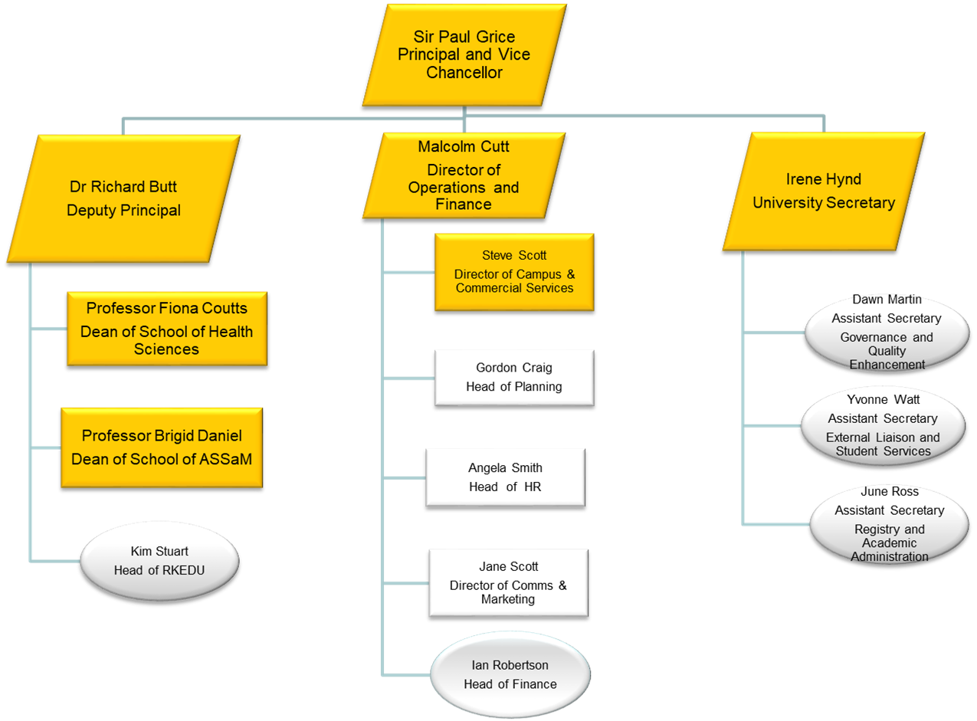

Your Internal
Contacts

Department/Division email addresses
Admissions |  | admissions@qmu.ac.uk
Counselling |  | counselling@qmu.ac.uk
Careers |  | careers@qmu.ac.uk
Disability Advice |  | disabilityadvisers@qmu.ac.uk
Estates |  | assist@qmu.ac.uk
Finance |  | financeoffice@qmu.ac.uk
Graduate School |  | graduateschool@qmu.ac.uk
Human Resources |  | hr-staff@qmu.ac.uk
International Office |  | international@qmu.ac.uk
Marketing |  | marketing@qmu.ac.uk
Library (LRC) |  | lrchelp@qmu.ac.uk
Press Office |  | pressoffice@qmu.ac.uk
Research and KE |  | rkedu@qmu.ac.uk
ResLife |  | reslife@qmu.ac.uk
Security |  | securityaccessrequests@qmu.ac.uk
School Office |  | schooloffice@qmu.ac.uk
Student Funding |  | studentfunding@qmu.ac.uk
Sports | sportsreception@qmu.ac.uk
Student Services |  | studentservices@qmu.ac.uk
Students’ Union |  | union@qmu.ac.uk
Student Wellbeing |  | wellbeing@qmu.ac.uk

Helpful QMU Acronyms

APC – Academic Promotions Committee
APUC - Advanced Procurement for Universities and Colleges
ASSaM – Arts, Social Sciences and Management
AWAM – Academic Workload Application Model
BEaM – Business, Enterprise, and Management
CPD – Continuous Professional Development
CS – Campus Services
DNBS – Dietetics, Nutrition and Biological Science
DSE – Display Screen Equipment
EA – Executive Assistants/Support
FEC – Full Economic Costing
FOI – Freedom of Information
H&T Academy – Hospitality and Tourism Academy
HESA – Higher Education Statistics Agency
HERA – Higher Education Role Analysis
HOD – Head of Division/Department
HR – Human Resources
HS - Health Sciences
ITS – Information Technology Services
KE – Knowledge Exchange
KIS – Key Information Sets
LRC – Learning Resource Centre
MCO – Marketing and Communications Office
MCPA – Media, Communication, and Performing Arts
MFD – Multi-function Device
NSS – National Student Survey
OTAT – Occupational Therapy and Art Therapy
PER – Performance Enhancement Review
PPR – Podiatry, Physiotherapy, Radiography
PPR – Professorial Remuneration Committee
PhySoc – Psychology and Sociology
QELTA – Quality Enhancement if Learning, Teaching and Assessment
QMUTU – Queen Margaret University Trade Unions
R&R – Reward and Recognition
REF – Research Excellence Framework
RILO – Recruitment and International Liaison Office
RGCU – Research, Grants and Contracts Unit
RKEDU - Research and Knowledge Exchange Development Unit
SFC – Scottish Funding Council
SHS – Speech and Hearing Sciences
SME – Small, Medium size enterprise
SLT – Senior Leadership Team
SU – Students Union
TNEP – Transnational Educational partnerships
TRAC –Transparent Approach to Costing
VAP – Vacancy Approval Panel
VOIP – Voice activated telephone system

Your Induction
DEVELOP Plan

During your first week you will meet with your line manager to discuss your job responsibilities as detailed in your job description. The purpose of this meeting will be for you and your line manager to understand how they can support you. Your Induction DEVELOP Plan can be tailored to your individual needs, whether it’s learning the QMU internal systems such The Hub, Blackboard, using the library facilities etc. Furthermore the session will also be an opportunity for you both to understand what your areas of development are in relation to your role responsibilities. Following the meeting it will be for you and your line manager to agree on development areas and put a structured plan in place to ensure you receive the necessary support to develop in these areas during your probationary period. The HR team runs formal training throughout the academic year via the DEVELOP calendar, all staff are entitled to attend these training courses to develop their skills in their roles following agreement from their line manager. The DEVELOP calendar can be accessed here and you can book onto any course via the HR self-service system iTrent, which can be accessed here. Your training can more informal on the job training i.e. self-training, shadowing a team member or specific line manager/induction buddy training sessions etc.

Your Induction DEVELOP Guidance | Timescale | Owner(s) | Completion date
Required – Meet with your line manager/mentor to discuss Your Induction DEVELOP Plan | Week 1 | LM/Mentor/New employee
Required – Meet with your line manager/mentor to agree Your Induction DEVELOP Plan and set know developmental objectives based on review of job description.  Academic only – agree Academic Workload Model plan (AWAM) - finalise teaching commitments and research expectations. In line with REF commitments academic objectives must be set in first month of employment. | Week 1 | LM/Mentor/New employee
Required - Agree with your line manager/mentor when you will hold regular check in review meetings during probationary period  NB All new employees – Probationary period recommends formal review meetings at the 2 month, 4 month and 6 months stage. | Week 1 | LM/Mentor/New employee

Your Induction DEVELOP Plan (as agreed in Week 1 with line manager and induction buddy involvement)

Identified Development objective | Support Required (training formal/informal) | Required change | Timescale
1.

2.

3.

4.

5.

6.

Your e-learning
Induction
Training Plan

There are a range of e-learning modules available to all staff via our e-learning platform. Please note that there are 4 mandatory e-learning courses that all new employees are required to complete within their probationary period (see below table).

Please discuss with your line manager which recommended e-learning modules may be applicable for your role. For example if you have line manager responsibilities then you would be expected to complete the recruitment and selection and Inclusion Leadership modules. Or if you have joined an internal support function then it would be likely that you would benefit from completing the customer service module.

Click here to access the e-learning platform (Note to log in enter your network user name and password)

E-Learning module | Mandatory/Optional | Completion date
Data Protection (including GDPR) | Mandatory
Equality & Diversity | Mandatory
Bribery Act | Mandatory
Unconscious Bias | Mandatory
Equality & Diversity in REF 2021 (academic specific) | Recommended
Inclusion Leadership | Recommended
Safeguarding | Recommended
Customer Service | Recommended
Environmental Sustainability | Recommended
Recruitment & Selection | Recommended

2 Month Induction
Review Meeting

Review Date:
Attendees:
Reflections on integration and work performance: | Employee feedback:
Guidance:
Consideration given to settling into the team and the working environment. Are you feeling connected, part of the team and supported from a well-being and job training perspective.

This review is also an opportunity for the employee and line manager to take stock of what elements of the role the new employee has met the needs of the role and furthermore what elements of the role the new employee could develop in.
 | Line manager feedback:
Progress made against Your Induction DEVELOP Plan: | Employee feedback:
Guidance: Opportunity for the employee and line manager to consider the progress been made against the DEVELOP Plan objectives. Are there any new objectives based on feedback that should be added into the plan. Finally consider any mitigating circumstances that have impacted progress against meeting these objectives and how this can be resolved.

 | Line manager feedback:

4 Month Induction
Review Meeting

Review Date:
Attendees:
Reflections on work performance: | Employee feedback:
Guidance: A further opportunity at the 4 month stage for the new employee and the line manager to meet to discuss how the new employee feels they are settling into their role/team and the wider university.

New employee and line manager to consider how they are performing since the previous review. Opportunity for the employee to consider if they require any further support and agree with their line manager/mentor what this is. If there were any key areas of development highlighted at the 2 month review stage then at the 4 month stage there should be reflections on these and if there is any further support required to meet the needs of their role built in the employee’s Your Induction DEVELOP Plan.
 | Line Manager feedback:
Progress made against Your Induction DEVELOP Plan: | Employee feedback:
Guidance: Opportunity for the employee and line manager to consider the further progress been made against the Your Induction DEVELOP Plan objectives. Are there any new objectives based on feedback that should be added into the plan. Finally consider any mitigating circumstances that have impacted progress against meeting these objectives and how this can be resolved.

 | Line Manager feedback:
6 Month Induction
Review Meeting

This is the final review meeting of Your Induction Plan/probationary period and the requirement at this meeting is for your line manager to confirm if you has successfully completed Your Induction Plan and are meeting the expectations of your role and working effectively within your wider team. From your perspective this final review is for you to consider and feedback if you feels valued and supported by their line manager and your wider team. This Plan has been created in line with the guidance in the Probationary Policy and following successful completion of this plan the HR Partner will send written confirmation formally acknowledging that you have completed your probationary period. There may be cases where an employee requires further support to meet the needs of their role and this will be discussed at this meeting with the possibility of the probationary period being extended for a reasonable period of time to allow the employee to improve in those highlighted areas of development to meet the needs of the role.

Review Date:
Attendees:
Reflections on work performance: | Employee feedback:
Guidance: At this meeting it would worthwhile to reflect over the last 6 months from an employee and line manager perspective.

 | Line Manager feedback:
Progress made against Your Induction DEVELOP Plan: | Employee feedback:
Guidance: Consideration given to if the Your Induction DEVELOP Plan has been fully completed. This includes meeting all the DEVELOP Plan points and also completed all the mandatory e-learning training courses.

The line and employee should agree based on this plan what the employee’s job objectives and DEVELOP Plan will be over the remaining part of the Academic year. These objectives should be added to the YourContribution system and this should now be the system used to support performance and career development.

 | Line Manager feedback:

On completion of Your Induction Plan please return a copy to your line manager who will be responsible for return a final copy to the HR Department.

