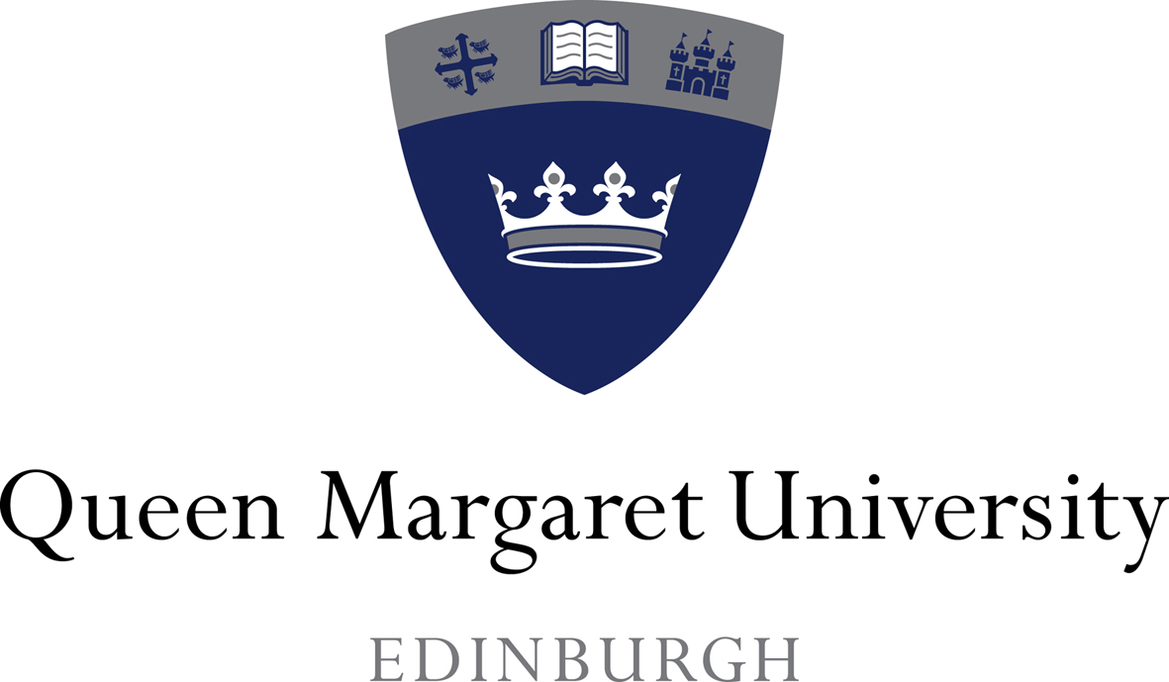

MAINSTREAMING REPORT

with associated reviewed

Equality Outcomes and Employment Information

APRIL 2017

MAINSTREAMING REPORT with associated reviewed Equality Outcomes and Employment Information

CONTENTS PAGE

Introduction 2

Section 1: Update on mainstreaming activity 3

Section 2: Equality Outcomes: Reporting on progress 2015-2017. 10

Section 3: Outcomes 2017-21 34
Section 4: Employment information 41
Section 5: Resources 41

Section 6: Management information – student population head count 42
(excluding based overseas in collaborative
partnership organisations)

Appendices: Associated Reviewed Employment Information

1 Staff Equalities Data
2 Equal Pay Review

INTRODUCTION

Queen Margaret University is pleased to publish this report, which sets out progress on mainstreaming equality and establishes a number of outcomes for the period 2017-2021.

Under the requirements of the Public Sector Equality Duty (PSED) introduced in the Equality Act 2010 (Specific Duties) (Scotland) Regulations 2012, the University is required to report on how it is mainstreaming equality. The specific duties are stated as aiming to help listed authorities to better meet the general duty and are designed to help develop evidence-based policies and practices, improve transparency and accountability, and deliver better outcomes for everyone in Scotland.

To meet the specific duties, the University is required to:

- report on progress on mainstreaming the general duty into all functions;
- develop and publish a set of equality outcomes that cover all protected characteristics (or explain why not all protected characteristics are covered);
- assess the impact of policies and practices against the needs of the general duty;
- gather and use information on employees;
- publish gender pay gap information;
- publish statements on equal pay for gender, race and disability;
- have due regard to the general duty in specified procurement practices;
- publish information in a manner that is accessible.

In 2016, the Scottish Government amended the specific duties to introduce a new requirement on listed bodies to publish the gender composition of their boards and to produce succession plans to increase the diversity of their board.

We consider that there has been significant movement towards mainstreaming equality and diversity throughout the University in the period since the publication of the University’s original report in April 2013. Equally, however, we recognise that we need to continue to establish outcomes where we have evidence to suggest inequality, with such evidence providing the basis for targeted action, including enhanced policy and practice.

Throughout this Report, the University has had due regard to the general duties as specified under the Equality Act 2010, and which require the University to:

- Eliminate unlawful discrimination, harassment, and victimisation.
- Advance equality of opportunity by having due regard to removing or minimising disadvantage, meeting the needs of a particular group that are different from the needs of others and by encouraging participation in public life; and
- Foster good relations by tackling prejudice and promoting understanding.

The equality outcomes reflect the protected characteristics of Age, Disability, Faith/belief, Gender identity, Marriage/civil partnership, Pregnancy and maternity, Race, Sex and Sexual orientation.

The University also seeks to remove inequality created by social and economic deprivation in line with Scottish Government objectives and set out in the University’s Outcome Agreement with the Scottish Funding Council (SFC)
http://www.sfc.ac.uk/funding/Fundingdecisions/FundingDecisions.aspx

This Report has been developed through the Equality and Diversity Committee, the membership of which represents staff and student stakeholders, and includes representation from each of the recognised Trades Unions. The report and has been approved for publication by the Chair of the University Court under powers delegated to the Chair by the University Court at its meeting on 5 April 2017.

SECTION 1: UPDATE ON MAINSTREAMING ACTIVITY

1.1 Mainstreaming Equality

Mainstreaming describes the process by which equality and diversity are brought into the core of an institution’s work and integrated into day-to-day activities. It is the process by which equality and diversity are considered in relation to all functions, including the development, implementation and review of policies and processes, supported by training and development. For Queen Margaret University, it means ensuring that equality sits at the heart of its mission, strategy, and operational delivery, in order to create a structure and a culture that embraces and advances equality and diversity.

It was recognised by the Scottish Ministers in their Proposals published in 2013 that “fully mainstreaming equality is a long term improvement journey”. It is a longitudinal process that focuses initially on adapting process and procedure but eventually translates into a way of thinking. Queen Margaret University is working to ensure that equality is embedded in the culture and structure of the University so that it better serves its communities. As reported below, the University continues on its improvement journey, having secured some areas of significant progress, but we recognise too that there is more to be done.

1.2 Governance and Strategic Planning

1.2.1 University Court and Institutional Committees

Mainstreaming has significant implications for the way in which responsibility for equality and diversity is managed. It requires collective responsibility and implementation, coupled with leadership and commitment from the University Court and through the University’s governance and management structures and arrangements.

Embedding equality and diversity in our governance structures and in our strategic planning process is critical to mainstreaming equality and diversity, as is defining responsibilities, setting performance measures and monitoring progress against those measures.

While responsibility for mainstreaming equality and diversity within the University rests with all staff and students, the University Court is, as a matter of law, responsible for ensuring compliance with the Equality Act 2010 and for ensuring that the University meets its public sector equality duty (PSED) and the specific duties relevant to Scotland.

The University Court has a role therefore in overseeing the University’s performance of its legal duties and in ensuring that appropriate mechanisms are put in place that provide the necessary assurances from the senior management team that legal requirements are being met.

The University Court exercises such oversight through the Equality and Diversity Committee (EDC). The EDC is responsible to the University Court for the development of the strategic framework for equality in service provision and in employment across the University. The Committee is a Standing Committee of the Court, to which it reports at each meeting on its discussions, on the development of specific initiatives, and to which it presents policies and procedures for approval. In so doing, it has a function that reflects the general duties.

The Committee is convened by the University Secretary, who is also Secretary to the University Court, and includes in its membership a lay member of Court, appointed by the Court. Its wider membership seeks to be reflective of the staff and student body and to benefit from a range of perspectives. To that end, it has members drawn from each academic and professional service area of the University, as well as student and trades union representation.

The Equality and Diversity Committee has a remit to eliminate discrimination, advance equal opportunities and foster good relations by tackling prejudice and promoting understanding, thereby ensuring the University avoids the potential for discrimination on grounds of the protected equality strands.

The Committee’s remit goes beyond legislative compliance however. It aims to support delivery of key elements of the University’s Strategic Plan through policy development and the promotion of examples of good practice from both internal and external sources. It also seeks to develop and maintain effective networking and liaison in equality and diversity issues. This applies internally within the University and externally, with a particular focus on working relationships with professional equality experts and equality bodies such as the Equality and Human Rights Commission and the Equality Challenge Unit.

Along with its responsibility to develop and agree the institutional mission, the University Court has a role in ‘establishing a vision for equality, and in moving the agenda beyond compliance to an approach that ensures the richness and diversity of society are reflected and celebrated within the institution’.

We consider that we have made significant progress over the last 2 years in terms of the University Court’s approach to its equality duties, evidenced through policy development and through systematic review of the diversity of its membership. Progress in terms of the latter is described fully within pages 19 and 20 of Section 2 below.

A number of other Committees and structures within the University are concerned with eliminating discrimination, advancing equal opportunities and fostering good relations by tackling prejudice and promoting understanding, These include the Research Strategy Committee, the Student Experience Committee and the Widening Participation and Student Retention (WISeR) Board. The manner in which these committees contribute to advancing equality and diversity within the University is discussed further below.

1.2.2 Mission, Vision and Strategic Planning

The University’s refreshed Vision (April 2015) is to be ‘a University of ideas and influence’. The University’s Mission reflects the Vision, with a stated commitment to social justice and to being a community without borders. Underpinning the Mission and the Vision are the Values to which the University aspires, including “recognising equality and diversity in all we do”.
http://www.qmu.ac.uk/the_university/mission_statement.htm

A commitment to equality shapes the institutional Strategic Plan. All students, regardless of their background, will have equal opportunities to succeed and become graduates with a strong sense of ethical and social responsibility who can contribute to and influence the wider community.

Through supportive leadership, staff will be encouraged to think creatively and take considered risks. We will attract and retain good staff by valuing them through transparent promotion opportunities, appropriate staff development, inclusivity and equality, and through instilling in our staff a strong sense of social responsibility. The policy and practice of the University is that staff are afforded equal opportunities within employment, and that entry into employment, and progression within employment, is determined by personal merit and the application of criteria related to the duties of each particular post and the relevant salary structure.

Equality and Diversity continue to be a focus of the University’s Outcome Agreement with the Scottish Funding Council. The University’s Outcome Agreement 2017-20 focuses on our commitment to attract and retain students from a wide range of backgrounds, and to support them to achieve successful outcomes.

We are committed to widening participation amongst students who have previously been inhibited from entering Higher Education for social, economic or cultural reasons, but also to taking active steps to maximise their persistence and success. Our widening participation and retention strategy seeks to increase student numbers from non-traditional groups, including those that are: first generation to go to Higher Education; from low progression schools; reside in communities in the lowest 20% and 40% of the Scottish Index of Multiple Deprivation (MD20); articulating students from Scotland’s Colleges, disabled students, or those who are Care Experienced.

Over the period during which we have published an Outcome Agreement, we have adopted a definition of ‘under-represented groups’ that has extended beyond that of the narrow SIMD national indicator and have developed a range of initiatives to increase the participation and retention of those from a broad range of non-traditional groups. This includes disabled students, BME students, mature students, and male students studying Allied Health programmes.

The outcomes established in the University’s Strategic Plan and its Outcome Agreement are supported by a number of institutional strategies and policies.

The Student Experience Strategy exemplifies the University’s commitment to delivering high quality educational programmes that satisfy a range of professional and vocational needs but which also develop individuals for a broader role, both in future employment and society. The strategy sets out to ‘maximise the potential of the individual, irrespective of their background’, to ensure ‘sought-after’ graduates and postgraduates, who are well educated, creative, independent, and reflective citizens, with transferable skills of flexibility, ready for employment, reflecting a range of academic, multi-disciplinary and transferable skills, as well as an enthusiasm for lifelong learning.
It places the student at the centre of the educational provision. To support that aim, programmes will incorporate curricula and learning strategies that ‘recognise diversity in the student body’. It recognises the need for flexibility in patterns of attendance and the needs of all learners and seeks to develop academic and pastoral support structures that support the learner at all stages from pre-entry, entry, progression, graduation and post-graduation.
We are working to promote entry to, and provide education at, undergraduate and postgraduate level for all students, whatever their background. We are committed to enhancing the student experience through delivering equality across the protected characteristics and creating an inclusive learning environment; this applies to recruitment and admissions, to the curriculum, teaching and assessment, to welfare and support services, and to staff development and training.

In support of the above, we will continue to develop a range of co-ordinated performance indicators, qualitative and quantitative, that provide the basis of the evaluation of the student experience. These include:
    - Application and conversion rates.
    - Student retention and withdrawal measures.
    - Student attainment.
    - Survey results including the National Student Survey (NSS) and the QMU Student Survey.
    - Module evaluation.
    - International Student Barometer and [Home] Student Barometer results.
    - Focus groups.
    - Internal Staff/Student Liaison Committee feedback and/or feedback from Programme Representatives.
    - Annual Programme Review report.

We have made significant progress in collecting data on each of the protected characteristics which provides for improved reporting. Further information on this is provided in section 1.2.5 below.

The Senate, Student Experience Committee and the Equality and Diversity Committee receive detailed reports on student admission, progression, completion and attainment broken down by the protected characteristics. Specific reports are produced annually which set out statistics by gender, ethnicity and disability in relation to students who have submitted academic appeals, have submitted a complaint under the University’s formal Complaints procedure, or have been subject to action under the University’s Discipline or Fitness to Practise regulations. The total numbers recorded under the latter two procedures are small, and analysis under each of these processes suggests that there are no areas of concern in terms of equality of treatment of students.

Annual Monitoring Reports are produced by both academic Schools each year. This exercise is a crucial element of the University’s quality assurance and enhancement processes, providing an important opportunity for staff to evaluate the programmes for which they are responsible, and for the School Academic Board to exercise its responsibility for assuring academic standards and enhancing the quality of the student experience.

The template for production of the annual programme report includes a specific section, headed ‘Equality and Diversity’ which invites academic programme leaders to highlight ‘matters identified relating to the enhancement of equality and diversity and action taken or planned, whether in relation to recruitment, student support, curriculum content, or methods of learning, teaching and assessment’. Any matters identified at programme level are then reported through the composite School report, the template for which has a discrete section that invites the Dean to comment as set out above. This report is then considered by the School Academic Board (SAB), which is a standing Committee of the Senate.

The Student Experience Strategy also commits us to enhancing the student experience by recruiting, developing and retaining excellent staff who reflect the diversity of the student population.

We are committed to ensuring that our staff population is representative of the wider community. Monitoring of that is conducted through profiling of staffing. Evidence in support of that is presented in the Appendices to this report.

Our strong commitment to equality in research is promoted in a number of different ways, including through the HR Excellence Award for Researcher Career Development and further Athena SWAN recognition. Further details are set out within Section 2 below.

1.2.3 Equality Policy

The University adopted a revised Equality Policy in 2015, which, with the Mainstreaming Report, replaced the University’s Single Equality Scheme. The Equality policy articulates the University’s approach to Equality in relation to staff and students. Amongst its provisions are that:

- Staff and students at the University are expected to treat others with respect at all times and to challenge discriminatory behaviour, attitudes or practices whenever they occur.

- In support of the above, the University will provide opportunities for staff and students to participate in learning opportunities that enable them to consider their own prejudices and adopt good practice.

- In relation to staff, the policy confirms the University’s position, which is that staff are afforded equal opportunities within employment, and that entry into employment with the institution, and progression within employment, will be determined only by personal merit and the application of criteria which are related to the duties of each particular post and the relevant salary structure.

- It is in the best interests of the University and everyone who works within the University to ensure that whenever employment opportunities arise, we consider the human resources, talents and skills available throughout the community. Within the framework of the law, we are committed, whenever practicable, to achieve and maintain a workforce that broadly reflects the community in which we operate and this will include using diverse sources of recruitment and adverts which target specific groups where permissible. The University will also provide fair and accessible opportunities for training and promotion for staff.

- In relation to students, we are committed to enhancing the student experience through delivering equality across the protected characteristics and creating an inclusive learning environment. The University encourages early disclosure of disability to allow for the provision of suitable reasonable adjustments prior to entering the institution.

- The University will operate fair and transparent procedures for student assessment, progression, attainment of awards and involvement in other University activities.

- The University will promote the use of inclusive language and avoid the use of words or phrases which are discriminatory or exclusive in all University publications and correspondence.

- The University seeks to increase student numbers from non-traditional groups; extend collaborative working relationships; promote staff understanding of diverse student groups and create an appropriately supportive infrastructure.

- The Court shall promote mainstreaming and ensure equality is an integral part of the planning process. The Court shall also take active measures to encourage diversity in membership and the business of the Court and actively involve students in decision making and policy development.

- The University will ensure a visible commitment to equality in modules and programmes and that all teaching is equality proofed. The University will celebrate and promote good practice in this regard.

- In research, the University will continue current good practice under the Research Excellence Framework and will build on this good practice in the future. The University will celebrate and promote good practice in research by the use of case studies and promotional material.

- The University will maintain its Athena SWAN awards and seek to obtain further recognition to promote its good practice.

- The Equality and Diversity Committee will ensure that the Equality policy and its aims are enacted throughout the University by the scrutiny of emerging policy and procedure under the Equality Impact Assessment regime and through reporting on mainstreaming and the equality outcomes. Student recruitment, retention and progression statistics will be monitored and feedback under student surveys reviewed to ensure the student experience is mapped to this policy. Employment statistics will be reviewed by the Equality and Diversity Committee and published in line with the Scottish specific duties to ensure that, in terms of employment, the University is meeting the aims under this policy.

- The University will continue to monitor its teaching and learning practice via Annual Monitoring Reports for both Schools and through the quality assurance and quality enhancement process.

- The University will commit to maintain its Athena SWAN awards and the good practice established through the Concordat and the Research Excellence Framework.

1.2.4 Equality Impact Assessment

As part of its mainstreaming approach, the University undertakes Equality Impact Assessments (“EIAs”) when reviewing and developing strategy, policy and process. A key indicator of Chapter B4 of the QAA’s Quality Code states that “a commitment to equity guides higher education providers in enabling student development and achievement”. This allows providers to take into account fairness, inclusion and accessibility. The Code highlights the importance of effective equality impact assessment.

We recognise that not all staff are involved in the EIA process, and that we have more to do in terms of expanding the pool of trained staff. We are currently in the process of auditing all formal University policy statements/regulations, with a view to producing a definitive register which sets out: policy owner, date of approval/last review and date of EIA. This action forms one of our Equality Outcomes for the lifetime of this report.

1.2.5 Management Information

We have in place management information capability that provides us with the basis to monitor and evaluate our performance across a wide range of indicators. We recognise though that the usefulness of such management information is reliant on our capacity to collect data and to produce resulting meaningful analysis. This is an area in which we have made significant progress over the past 2 years in terms of student data collection and analysis, and through the further development of our HR ITrent system.

In terms of student data, we have improved our capacity to collect information as suggested by the reduction in the percentage of ‘unknowns’. As students are required to provide this information as part of the annual matriculation process, we have been able to fill in historical unknown values, improving the accuracy of our historical data also.

This applies across each of the protected characteristics groups as follows:

Comparative data 2012/13 to 2016/17

(Note: Data reported for Session 2016/17 is at 30 April 2017)

GENDER | 2012/3 |  | 2013/4 |  | 2014/5 |  | 2015/6 |  | 2016/7
Gender not known | 0 | 0% | 0 | 0% | 0 | 0% | 0 | 0% | 0 | 0%

Indicative numbers for 2016/7 show we continue to have no refusals in terms of gender data.

ETHNICITY | 2012/3 |  | 2013/4 |  | 2014/5 |  | 2015/6 |  | 2016/7
Information Refused | 109 | 2.3% | 73 | 1.5% | 61 | 1.2% | 44 | 0.9% | 44 | 0.9%
Not Known | 37 | 0.8% | 30 | 0.6% | 27 | 0.5% | 20 | 0.4% | 4 | 0.1%

The percentage of refusals in terms of ethnicity has been on an encouraging downward trend from the 2.3% refusal rate in 2012/3. In 2015/6, the percentage of refusals was 0.9% and indicative figures for 2016/7 suggest this has been maintained. The number and percentage of unknowns has also seen a downward trend to an indicative 2016/7 0.1%.

RELIGIOUS BELIEF | 2012/3 |  | 2013/4 |  | 2014/5 |  | 2015/6 |  | 2016/7
No religious belief | 1081 | 22.4% | 1433 | 29.5% | 1708 | 34.4% | 1888 | 38.8% | 2026 | 42.4%
Information refused | 72 | 1.5% | 118 | 2.4% | 121 | 2.4% | 144 | 3.0% | 137 | 2.9%
Not known | 2414 | 50.0% | 1772 | 36.4% | 1465 | 29.5% | 1164 | 23.9% | 1033 | 21.6%

Religious belief remains an optional question, which means that the unknowns remain relatively high when compared with other protected characteristics. However, we are still able to evidence an improvement in the reduction of unknowns, from 50% in 2012/3 to an indicative 21.6% in 2016/7. Almost 80% of our students now complete this optional question during online matriculation.

Analysis of the ‘unknown’ values for religious belief demonstrate a reduction in numbers and percentage, compared with the values for ‘no religious belief’, which has seen a proportionate increase. This may indicate that those who previously disregarded the question as not being applicable are now indicating that they have no religious belief.

SEXUAL ORIENTATION | 2012/3 |  | 2013/4 |  | 2014/5 |  | 2015/6 |  | 2016/7
Information refused | 112 | 2.3% | 140 | 2.9% | 165 | 3.3% | 177 | 3.6% | 179 | 3.8%
Not known | 2618 | 54.3% | 2007 | 41.3% | 1650 | 33.3% | 1246 | 25.6% | 1055 | 22.1%

As with religious belief, it is not mandatory to provide this information during annual matriculation. However, we have seen a marked increase in the percentage of students responding to this question, with an indicative 22.1% ‘unknown’ in 2016/17 compared with 54.3% ‘unknown’ in 2012/13.

The percentage of students responding to the question, but selecting ‘Information Refused’, appears to have increased from 2.3% in 2012/13, to an indicative 3.8% in 2016/17.

GENDER IDENTITY | 2012/3 |  | 2013/4 |  | 2014/5 |  | 2015/6 |  | 2016/7
Information refused | 28 | 0.6% | 43 | 0.9% | 47 | 0.9% | 51 | 1.0% | 53 | 1.1%
Not known | 2354 | 48.8% | 1708 | 35.1% | 1366 | 27.5% | 1075 | 22.1% | 1011 | 21.2%

Again, in line with religious belief and sexual orientation, more students appear willing to provide data for the optional question regarding gender identity. The indicative percentage for 2016/17 shows 21.2% of students did not answer the question, compared with 48.8% in 2012/13. The percentage of students responding to the question, but selecting ‘Information Refused’, has increased from 0.6% in 2012/13, to 1.1% in 2016/17.

We will continue to work to improve the percentage of unknowns, but we consider that the information available to us does allow us to produce management reports that are significant in statistical terms. We are able to produce live ‘on time’ reports that are accessible to all staff, either through direct access to the reports, or by request. In relation to student retention and progression, for example, we provide reports on a monthly basis to all programme leaders and senior academic managers so that any issues emerging are identified. A full suite of Management Information reports on student progress and achievement broken down into each of the protected characteristic groups is included in the Annual Reports for each programme.

Management information and supporting commentary on our staff is set out in Appendices 1 and 2 of this report.

SECTION 2: EQUALITY OUTCOMES TO 2017: REPORTING ON PROGRESS

As part of the mainstreaming process, and to comply with the specific duties, the University is required to publish, undertake and report on progress on equality outcomes.

Equality outcomes are not targets or processes. An outcome is an aspirational end result which, in the short term, will change awareness, knowledge, skills and attitudes, and in the longer term, will change behaviour, put a focus on equality in decision making and improve social and environmental conditions.

In our Mainstreaming Report 2013-17, we established thirteen Equality Outcomes. In our progress report in April 2015, we reduced these to twelve outcomes on the basis that outcomes relating to the retention of male students in health sciences and in performing arts had been achieved. A new outcome relating to the representation of males in Health Sciences was added to the suite of outcomes.

The equality outcomes that form the basis of reporting in this report are therefore:

Outcome 1: Ensure that the workforce of the University represents the community it serves.
Outcome 2: Increase retention of mature students.
Outcome 3: Increase the representation of BME students.
Outcome 4: Ensure that our HR policies promote inclusive employment opportunities and provide clear advice to all staff on opportunities to work flexibly.
Outcome 5: Ensure that disabled staff and students’ needs are fully accommodated.
Outcome 6: Ensure students meet employers’ requirements.
Outcome 7: Increase awareness of hate crime and decrease tolerance of this crime.
Outcome 8: Ensure that students with caring responsibilities are not disadvantaged.
Outcome 9: Embed equality and diversity in the curriculum and in research.
Outcome 10: Demonstrate our commitment to advancing women's careers in STEM subjects via ATHENA SWAN.
Outcome 11: Increased equality and diversity in research careers.
Outcome 12: Increase the representation of males in health sciences.

As set out in the table and paragraphs that follow, we consider that we have made significant progress during the lifetime of the Mainstreaming Report across all areas. Not all outcomes have been attained and not all outcomes will be achievable in isolation - some require partnership working. Some outcomes may not be achievable at all due to larger societal influence, but it is still important nevertheless to recognise those that fall into that category.

Outcome | Evidence Base | Possible activities | PC(s) and general duty | Responsibility
Outcome 1  Ensure that the workforce of the University represents the community it serves | HESA, Staff Survey 2012 and 2015, Internal HR information | - Promote equality and diversity in selection of staff and in consideration of job descriptions.  - Review arrangements for encouraging people with protected characteristics to apply for positions.  - Ensure all committees and decision making bodies of the University are representative of its community. | Age, Disability, Gender identity, Race, Gender, Sexual orientation, Pregnancy and maternity, Faith and belief; Eliminate unlawful discrimination, foster good relations and advance equality of opportunity. | Head of Human Resources, University Secretary
Outcome 2  Increase retention of mature students | HESA, Student Retention Project Statistics, Outcome Agreement 2015/16 and onwards. | - Target mature students as part of the Student Retention Project. | Age and Gender. Advancing equality of opportunity, eliminate unlawful discrimination and foster good relations. | WISeR Board
Outcome 3  Increase the representation of BME students | HESA, Student Retention Project Statistics, Outcome Agreement 2015/16 and onwards. | - Target BME students as part of the Student Retention Project. | Gender and Race. Advancing equality of opportunity, eliminating unlawful discrimination and foster good relations. | WISeR Board
Outcome 4  Ensure that our HR policies promote inclusive employment opportunities and provide clear advice to all staff on opportunities to work flexibly | Staff Survey 2012 and 2015, Internal HR information  Revised via further analysis of the Staff Survey results | - Raise awareness of HR policies amongst all staff.  - Continue to consult with key stakeholders over the revision of existing and the development of new policies and on the potential qualities impacts.  - Continue to develop and revise HR policies based on best practice and legislative changes taking into account all of the protected characteristics. | Gender. Advancing equality of opportunity and eliminating unlawful discrimination. This category was hard to reconcile with fostering good relations though this may occur. It was felt important to include this to allow males in the workforce to have the same opportunities as females. | Head of Human Resources

Outcome 5  Ensure that disabled staff and students’ needs are fully accommodated | Reports on discipline, FTP, complaints and appeals, Staff survey 2012 and 2015, Students’ Union, Student Retention Project Statistics, Management Information Reports from SITS. | - Develop improved processes for staff to access support;  - Develop and publicise information on the support available for staff;  - Work with external bodies to develop a staff culture which promotes good health;  - Develop further awareness of issues relating to students with specific learning difficulties or disabilities;  - Embed a culture of improved and necessary support for mental health issues;  - Continue to work towards an inclusive environment for disabled students;  - Reduce the overall number of specific adjustments recommended in favour of a mainstreamed approach;  - Encourage early disclosure;  - Ensure the campus facilities and surrounding transport arrangements are fit for purpose. | Disability. Advancing equality of opportunity, eliminating unlawful discrimination and fostering good relations. | Head of Student Services, Head of Human Resources and Director of Campus Services
Outcome 6  Ensure students meet employers’ requirements | Edinburgh Partnership, Edinburgh Council, NHS Lothian, Lothian and Borders Police, Lothian and Borders Fire and Rescue Service | - Ensure students are aware of the general duty and embed a culture of fostering good relations;  - Work with external agencies to ensure that students and employers are aware of each other’s obligations and the expected requirements of junior staff. | Age, Disability and Gender. Advancing equality of opportunity, eliminating unlawful discrimination and fostering good relations. | Deans of Schools and Head of Student Services
Outcome 7  Increase awareness of hate crime and decrease tolerance of this crime | Edinburgh Partnership, Edinburgh Council, NHS Lothian, Lothian and Borders Police, Lothian and Borders Fire and Rescue Service, Reports on discipline, FTP, complaint and appeals, International Student Review | - Promote good relations between groups of different protected characteristics by the introduction of an Equality and Diversity week and working with external agencies;  - Introduce a staff LBGT network;  - Develop and implement a trans persons policy;  - Work with external agencies to develop understanding of the ways to report hate crime. | Disability, Faith/belief, Gender identity, Race, Gender, Sexual orientation. Eliminate unlawful discrimination, advance equality of opportunity and foster good relations. | Convener of Equality and Diversity Committee
Outcome 8  Ensure that students with caring responsibilities are not disadvantaged | Student Retention Project Statistics, Students’ Union, Outcome Agreement 2015/16 and onwards. | - Introduce a pregnancy and maternity/paternity policy for students;  - Review arrangements for suspension of studies to make explicit the additional support pertaining to caring responsibilities. | Gender, Age, Disability, Pregnancy and maternity, marriage/civil partnership. Advancing equality of opportunity and eliminating unlawful discrimination. This outcome may not foster good relations in relation to all the protected characteristic groupings but given the focus of the University’s Outcome Agreement, it was thought important to include. | Head of Student Services and University Secretary
Outcome 9  Embed equality and diversity in the curriculum and in research | REF, Outcome Agreement 2015//16, Strategic Plan 2015-20, School Annual Monitoring Reports | - Introduce case studies outwith stereotypes;  - Have mentors who are knowledgeable in relation to particular cultures or beliefs;  - Reduce the barriers students face in accessing study;  - Implement widespread training and awareness of cultural differences;  - Ensure validation panel have requisite training and establish whether equality and diversity is embedded within the curriculum | Age, Disability, Faith/belief, Gender identity, Marriage and civil partnership, pregnancy and maternity, Race, Gender and Sexual orientation. Eliminate discrimination, advance equality of opportunity and foster good relations. | Head of RKEU and Deans of Schools
Outcome 10  Demonstrate our commitment to advancing women's careers in STEM subjects via ATHENA SWAN. | Athena SWAN bronze award. Membership and Participation in the Edinburgh Beltane.  Post REF 2014 submission to STEM subjects analysis. | - Increased public engagement activities in science communication.  - Roll out of the QMU Researcher in Residence in Scheme. | Gender. Eliminate unlawful discrimination, advance equality of opportunity and foster good relations. | Theme Leads.

Outcome 11  Increased equality and diversity in research careers. | REF 2014 Outcomes.  REF 2014 Equality Code of Practice.  AthenaSWAN  HR Excellence Award | - Diversity in the profile of staff submitted to REF.  - Promotion and implementation of the Equality Code of Practice.  - Implementation of the concordat action plan.  - Re-launch of the QMU Mentoring Scheme. | Age, Disability, Gender identity, Race, Gender, Sexual orientation, Pregnancy and maternity, Faith and belief; Eliminate unlawful discrimination, foster good relations and advance equality of opportunity. | Deans, Deputy Principal
Outcome 12  Increase the representation of males in health sciences | HESA, Outcome Agreement 2015/16 and updates, Data from internal figures on admissions and retention  School of Health Sciences Annual Monitoring Report | - Target recruitment to males;  - Work with Edinburgh Council, East Lothian  - Council and Midlothian Council to adapt attitude to caring professions in younger generations | Gender. Advancing equality of opportunity and eliminating  unlawful discrimination. This outcome was selected due to the low percentage of males in Health Sciences. It may have an indirect effect of fostering good relations though the primary aim of this outcome is foster the two parts of the general duty mentioned above. | WISeR Board

Outcomes 1 and 4: Ensure that the workforce of the University represents the community it serves/Ensure that our HR policies promote inclusive employment opportunities and provide clear advice to all staff on opportunities to work flexibly.

Appendix 1 of this report sets out equalities data in relation to our academic and professional services staff.

The majority of staff at QMU are female; our data shows female staff represent 66% of our overall staffing population. This was the case in both 2014/15 and 2015/16. On average, female staff also form the majority of staff within the Scottish HEI sector, with 54% of all staff being female in the reporting period 2014/15. The overall sector trend indicates that the proportion of female academics is steadily increasing; this trend is also evident at QMU, with the percentage of female academic staff increasing from 67% (2014/15) to 69% (2015/16).

Those declaring a disability at QMU remained steady over the period 2014/15 and 2015/16 at 3.9%, compared to the Scottish HEI benchmark of 3.3%. The percentage of staff ‘declining to say’ has decreased from 11.6% of staff in 2014/15 to 10.8% of staff in 2015/16.

In our statistics, we group staff by age into the following categories: 16-24; 25-34; 35-44; 45-54; 55-64 and 65+. In 2014/5 and 2015/16, data show a steady increase in overall staff numbers, with the highest staff concentration being reached within the 45-54 age range (28.6% in 2014/15, and 29.5% in 2015/16). Staff numbers reduce in the age categories that follow. It is noted that Equality Challenge Unit statistics categorise age groups differently to QMU. QMU banding of age groups will be altered for the next reporting period to allow benchmarks to be considered.

The BME staff headcount at QMU increased slightly between 2014/15 (3.1%) and 2015/16 (3.7%) but remains lower than the Scottish HEI benchmark of 6.7%.

Sexual orientation was introduced into the staff HESA return in 2012/13, and in the 2014/15 HESA return, 72.2% of Scottish HEI’s returned data. At QMU, LGBT staff represented 3.3% (2014/15) and 3.7% (2015/16) of all staff compared to a UK HEI benchmark of 1.4%. It should be noted that those declining to say represented 60% (2014/15) and 53.2% (2015/16) at QMU, and 70% in the UK HEI benchmark data.

Along with sexual orientation, data on religion and belief was introduced into the staff HESA return in 2012/13. In the 2014/15 return, 61.1% of Scottish HEI’s returned data. A high proportion of staff at QMU decline to say, with 69% (2014/15) and 66% (2015/16) being in this category. This is consistent with the Scottish HEI benchmark, with 69% (2014/15) being recorded under the ‘information refused’ or ‘blank’ category.

We recognise that, for equalities data to be meaningful and to impact on policy development, we need staff to be confident in disclosing data on their protected characteristics. This is one of the action points arising from the 2015 Staff Survey, follow-up to which has been coordinated by the Staff Survey Steering Group, whose membership is drawn from all areas of the University. The number of respondents who chose to select the ‘prefer not to say’ rather than declare protected characteristics (disability, sexuality, nationality and religious belief) was high across all questions within the staff survey, with the highest prefer not to say response being in relation to religious belief.

The table below shows the percentage of respondents that preferred not to say when asked for their protected characteristics.

Protected Characteristic | % Responses Prefer Not to Say
Disability | 5.0%
Sexuality | 12.5%
Nationality | 2.6%
Religious Belief | 20.5%

This impacted on the statistical significance of some of the results, particularly where it has been assumed that those who ‘prefer not to say’ have adopted that position on the basis that they have a protected characteristic. The University has been working with ECU Scotland to address this, and an action plan is being put in place for the next Staff Survey.

Again, with the support of the ECU, the Equality and Diversity Committee will work with staff groups to improve satisfaction levels of those staff respondents who declared a disability in particular, 44% of respondents with a declared disability having responded positively to the statement ‘I am actively seeking to leave the employment of the university’ compared with 26% of overall respondents. As a ‘Disability Confident’ accredited employer, we are committed to core actions and activities to support disabled people under the themes: ‘Getting the right people for your business’ and ‘Keeping and developing your people’.

In support of the our commitment to embedding transparent and fair practices in the recruitment and selection of our staff, all HR policies including those concerned with the recruitment and selection of staff are subject to robust equality impact assessment.

The University’s Recruitment and Selection Policy states that any applicant declaring a disability who meets the minimum criteria for the position, as described in the job description, will be invited to interview.

In order to ensure fair treatment the University adopts a competency based approach to interviews; all those participating in appointment panels are offered training and HR support in order to enrich their understanding and ensure consistent application of the competency based approach. The competency based approach supports the objective assessment of competencies linked to the job description reducing the potential for bias in selection decisions.

In addition to face to face training and HR support, the University launched in February 2015 a range of e-learning modules, including on unconscious bias. These modules have been made available to all staff. In April 2016, Unconscious Bias e-learning training was made mandatory for all staff participating in selection panels for staff recruitment. Most recently in March 2017, ‘Unconscious Bias’ training was undertaken by members of the Equality and Diversity Committee and University Court members. Consideration is being given to further face to face training in this area for managers and recruitment panel members.

At the last HESA data return, gender balance in terms of Professorial staff was 50% female and 50% male. Subsequent movement in staff altered that balance in favour of male professorial staff but recent recruitment has restored the balance. The relatively small size of the academic staff population of the University means that the loss of one or two staff can alter the gender balance significantly. We will continue to work to address any significant imbalance.

As advised earlier in this report, we are committed to the principle of equal pay for work of equal value, free from bias and based on objective criteria. The University recognises that under the Equality Act 2010, both women and men have the right to equal pay for work of equal value; this applies to all employees regardless of full or part-time status, casual or temporary contract or length of service. Equally, the University also recognises its duty to provide equal pay for work of equal value regardless of differences in age, race, nationality, ethnic or national origin, religion, sexual orientation, marital, civil partnership, parental status or disability.

The University has in place a pay and grading system which is used to assist in determining equal pay across the University. The pay and grading system is applied transparently, based on objective criteria, and free from unlawful bias.

The University’s policies and procedures associated with pay and remuneration have been developed and implemented with a view to eliminating unlawful bias and are systematically monitored and reviewed.

In order to put the University’s commitment to equal pay for work of equal value into practice we have undertaken to:

- Conduct an equal pay review on an annual basis in accordance with the Public Sector Equality Duty for all current staff and starting pay for new staff;
- Monitor the impact of our policies and procedures associated with pay and remuneration and take appropriate action where necessary;
- Provide guidance for managers involved in decisions about recruitment, pay, benefits and promotions.

Data set out in our Equal Pay Review suggests that, for all staff at all grades (data includes the Executive Board), there is a negative pay gap in terms of mean salary of some 0.37% between female and male employees ie in favour of male staff. If salaries of the Executive Board are excluded, there is a positive mean pay gap in favour of female employees of 1.02%. This has been the position over the last 4 years of such data being collected

If salaries of the Executive Board are excluded from the calculation, the mean pay gap is 1.02% in favour of female employees. A review of the mean pay gap over the last four years demonstrates that it has remained steady at 1%.

The median pay gap for employees is 6.13% in favour of women for employees on Grades 1-10 (including the Executive Board). This has remained constant over the last two years. When excluding the Executive Board salaries, the median pay gap in favour of women increases further to 9.30%, which again has remained constant with the previous year.

By way of context, the Equality Challenge Unit (ECU) report titled ‘Equality in higher education: staff statistical report 2016’, reported a negative mean female pay gap of 18.3% and median of 13.7% across the UK in HEIs. Furthermore, in Scotland the overall gender pay gap for HEIs was wider, with a mean negative female pay gap of 20.9% and median pay gap of 18.6%. In terms of benchmarking, QMU performs significantly better in terms of the pay gaps reported for UK and Scottish HEIs.

There are no significant pay gaps between Grades 1-9 for all employees. However at Grade 10 there is a significant pay gap, both mean and median, in favour of male salaries. The gap is sitting above the 5% mark. Detailed analysis of the data demonstrates that this significant pay gap is attributed to academic salaries. In particular, it is related to the Senior Academic and Professorial positions, where the gap is above 5%. Although there are a small proportion of individuals appointed to such position, this is an area that requires further investigation.
The Professional services salaries show no significant average or median pay gaps between Grades 1 - 7. At Grade 8, there is median pay gap of 6.7% in favour of female employees, which has increased from the previous year. In contrast, at Grade 9, the pay gap is significantly in favour of male employees, sitting above the 5% mark, despite there being over a 50% higher female population in Grade 9 roles.

Part time females academics (Grade 6 – 10) are paid a significantly higher salary according to the mean salaries in 2015 (-13.98%) and 2016 (-12.51%). In contrast, full time male academics (Grade 6 – 10) are paid significantly higher salaries than females, with a 7% pay gap which has remained steady over the last two years.

In analysing the data by protected characteristics, females between the ages of 35 – 44 are paid significantly less, with a median pay gap of 18.6%.

BME, LGBT and declared disabled populations are all paid less when compared with wider employee population, both from a mean and median calculation. However, it is acknowledged that employee data on ethnicity and sexual orientation is not as reliable given that a large percentage of the population is declared as unknown. Additional work needs to be undertaken in this area. This is an area for improvement across Higher Education organisations in the UK, as recognised in the ECU ‘Equality in higher education: staff statistical report 2016’.

We are one of 5 universities in Scotland that have made the real Living Wage commitment by becoming an accredited Living Wage employer. The University welcomed the Scottish Government’s Higher and Further Education Minister, Shirley-Anne Somerville, to celebrate the move on campus during Living Wage Week (30 October - 5 November 2016).

The Living Wage commitment will see everyone working at QMU, regardless of whether they are permanent employees or third-party contractors, receive a real Living Wage, which is significantly higher than the government minimum wage of £6.70 and the new minimum wage premium for over 25s of £7.20 per hour introduced in April 2016. The University’s third party contractors will adopt the Living Wage as and when existing contractual arrangements are renewed.

The Equality Act 2010 (Specific Duties) (Scotland) Amendment Regulations 2016 have introduced a new duty.

http://www.legislation.gov.uk/ssi/2016/159/regulation/4/made

Specifically, the regulations provide for the Scottish Ministers, from “time to time”, to gather information on the relevant protected characteristics of board members of listed bodies, to be aggregated into Scotland wide statistics on board participation. The Scottish Ministers are to provide that information back to listed bodies, for such bodies to publish in their mainstreaming reports:

• information on the gender composition of boards
• how they will increase the diversity of boards through succession planning, including use of data on protected characteristics

To date, no such monitoring has been undertaken by the Scottish Government, and we are therefore unable to comply fully with the reporting requirements. Nevertheless, we are able to report on gender balance in the composition of the University Court.

We have moved to collecting equality data in relation to Court members in support of our commitment to ensuring that there is an appropriate balance of independent members on the University Court in terms of equality and diversity. The data will provide the Court with the information it needs to ensure that its equality and diversity goals are being met by identifying where gaps in representation arise, allowing the Court to target recruitment activity to ensure that an appropriate balance is achieved.

The University Court’s approach to its equality duties is evidenced through policy development and through systematic review of the diversity of its membership.

Recruitment for independent or lay members during 2015-17 continued to address directly the diversity of membership in line with the commitment set out in our Mainstreaming Report and Outcomes that ‘all committees and decision making bodies of the University are representative of its community’. A diversity audit of current membership was conducted by the Nominations Committee so that recruitment took account fully of the balance of skills, attributes and experience of the current lay membership.

With advice from the Equality Challenge Unit (ECU), we have particularly sought expressions of interest from women, disabled people, ethnic minorities and applicants who would further enhance the diversity of the Court. Advertisements for vacancies were placed in a range of media, including, Women on Boards, with the intention of encouraging more female applicants. Again with the advice of the ECU, the person specification was revised so as to accommodate those without previous board level experience, but who were able to demonstrate a track record of success in professional areas of expertise.

At its meeting in December 2014, the University Court approved goals and policies in regard to the balance of its independent members in terms of equality and diversity as follows:

‘Queen Margaret University is committed to ensuring that the University Court (Court), Senate and all committees and decision making bodies of the University are representative of its community. In particular, the University will seek opportunities to address gender balance and to strengthen the representation and voice, amongst its lay membership, of all groups represented by Court.

To this end, the University is committed to achieving the following goals and targets:

- The University will work towards achieving practical gender balance amongst lay members of Court. Practical gender balance will be achieved where the lay membership of Court constitutes not less than 40% of either gender.

- The University will undertake an annual review of the equality and diversity characteristics of the Court or as a specific need for review is identified.

- In undertaking any recruitment activity concerning the appointment of lay members of Court, the Court will have regard to equality and diversity characteristics of the Court and will take positive actions to increase the likelihood of applications being submitted from applicants that would enhance the representative character of the Court.

- The University will harness appropriate opportunities to further promote and improve gender balance and enhance the representative character of the Court, Senate and other committees and decision-making bodies within the University including but not limited to making training on equality and diversity available to members of the Court.

Outcomes 2, 3, 5, 8
Increase retention of mature students/ Increase the representation of BME students/Ensure that disabled staff and students’ needs are fully accommodated/Ensure that students with caring responsibilities are not disadvantaged.

In terms of our student population, we continue to focus on ensuring that potential students from under-represented groups are fully informed about courses, admissions procedures and the student experience in order for them to make informed choices.

On the basis that we have adopted a wider definition of ‘under-represented groups’ that has extended beyond that of the narrow SIMD national indicator, we have included specific outcomes for protected characteristic groups in our Outcome Agreement with the SFC since 2011. We have developed a range of initiatives to increase the participation and retention of those from a broad range of non-traditional groups. This includes disabled students, BME students, mature students, male students studying Allied Health programmes, students from Care/Looked after backgrounds and students with Caring responsibilities.

We are committed to enhancing the student experience by creating and promoting an inclusive learning environment. This applies to recruitment and admissions, to the curriculum, teaching and assessment, to welfare and support services, and to staff development and training. We continue to benchmark and evaluate our performance in this area, primarily through the Equality and Diversity Committee and through the Widening Participation and Student Retention (WISeR) Board.

Our approach to widening access offers built in tailored support throughout the learner journey. To deliver on those commitments, we have invested carefully in people and structures. Our Outreach and Community Engagement Team work determinedly with a range of partners, including schools, colleges, community groups, third sector and voluntary agencies, and local councils, to maximise the opportunities of people in Edinburgh and the Lothians.

As our approach to widening participation has broadened, we have been concerned also to deepen our engagement with our communities with a view to raising aspirations at an early age. A key strategy has been collaboration with communities to de-mystify higher education and to empower individuals seeking to access higher education. We work with a number of East Lothian and Midlothian based community groups and initiatives that support local community development plans.

Our recruitment and admissions strategy is an important element of our commitment to increase applicants and entrants from non-traditional groups. This includes those that are the first generation to access Higher Education, from low progression schools, from the SIMD 20 and 40 quintiles, articulating students from Scotland’s Colleges, those who are Care Leavers, and those with protected characteristics.

Our contextualised admissions policy is based on the following key principles:

- Fairness – we will strive to use admission assessment methods that are reliable and valid.
- Transparency – details of our entry requirements will be published in our prospectus and on our website and will be clear and transparent to applicants and their advisers.
- Reflect our community – we are committed to admitting as wide a range of applicants as possible to reflect our community.
- Encourage participation – we will minimise barriers to applicants and encourage student persistence, progression and retention through our targeted pre-entry and transition support services.

The policy ensures that each application received by the University is considered carefully on its own merits, taking into account educational, professional and personal experience.

We will continue to identify and share best practice in the use of contextual admissions in a way that supports our aspirations, informs decision-making and encourages more applications from all backgrounds. We have made very significant progress in ensuring that applicants from deprived backgrounds and care-experienced learners are identified in admissions. Along with others in the sector, we will actively consider how and where it is appropriate to make adjusted offers to applicants who have markers of deprivation or underrepresentation.

We recognise that Care Leavers and those with a background in care are amongst the most under-represented groups in Higher Education. The number of applicants and entrants to the University from this group is too small for meaningful trend data to be used, but they continue to be a group identified by us for additional support in terms of the provision of a named contact, proactive identification of support services, and provision of additional financial support where available.

Through our partnership with Who Cares Scotland, we have established a Corporate Parent Policy based on our engagement during 2016 with care experienced young people residing in East and Midlothian. In May 2016, we hosted an event aimed at senior staff throughout the University and senior/guidance teachers from our partner schools in Edinburgh and Lothians. Representatives from Who Cares Scotland and 10 care experienced young people presented their stories and the Who Cares project to the audience. QMU staff have been working with all those involved to produce a film of the presentations so that they can deliver in schools throughout Scotland. We are active partners in East Lothian’s Looked After Children forum, which meets quarterly to share best practice.

Under our Policy and Procedure for Undergraduate Applications from Care Leavers, and those with a Background in Care, anyone who has been in the care of a local authority for at least 13 weeks, whether away from home or in the home, is considered to have a background in care, and is eligible for support in the form of pre- and post-entry advice, support and guidance, accommodation guarantees and help to access any appropriate bursaries and grants. The University recognises that care leavers may face additional barriers when applying to higher education and is committed to increasing the number of applications from those who have spent time in care.

We guarantee to make an offer of admission, or an offer of an interview or audition, to any care leaver who has the potential to meet our entry requirements for their chosen programme of study.

Care leavers are guaranteed a place in student accommodation (this includes those who live locally), and are provided with the opportunity to apply and receive a guaranteed interview for temporary part-time work opportunities offered by the Student Services, Outreach and Community Engagement and Recruitment teams. These include roles as Student Ambassadors, Student Guides and QMAdvance Assistants. All of this information is publicised through our website and in leaflets.

In developing our support for student carers, we partnered with Carers Trust Scotland to develop the QMU Student Carers’ Support policy. A student carer is defined by the Carers Trust Scotland: https://www.carers.org/scotland as “anyone who cares, unpaid, for a friend or family member who due to illness, disability, a mental health problem or an addiction cannot cope without their support”.

We are committed to ensuring that students with caring responsibilities are given the support they need to reach their potential. We recognise that students with caring responsibilities may be disadvantaged in terms of being able to devote the necessary time to study for qualifications for degree level study entry and whilst at University.

Applicants disclosing that they have caring responsibilities are considered under our contextualised admissions arrangements. Student carers are provided with support and advice that recognises that they may have limited opportunities for paid part-time employment whilst studying, as well as more limited opportunities for social engagement and integration with other students. We will continue to work with the Carers Trust Scotland to ensure that we are adopting very best practice in this area and have been invited by the Trust to deliver a keynote speech at their annual conference in March 2017 highlighting our work to date in establishing a sector-leading support policy for our students with caring responsibilities. Since 2016/17 we have also captured this information at the point of matriculation; this will be updated annually, to ensure we have baseline evidence to further support this group.

The University continues to work to actively recruit and retain students from the protected characteristic groups, including BME, disabled students, and mature students. We continue to perform well relative to the Scottish and UK Higher Education Sector and to benchmark our performance against the rest of the HE sector.

The latest Scottish Funding Council annual statistical publication on HE students and qualifiers in Scotland reports that:

- 58% of students at HEIs are female, a proportion that has been increasing since 2011.
- Subject groups with the highest proportions of female entrants were subjects allied to medicine (83%), Vet Science (79.7%) and Psychology (76.2%).
- The overall percentage of Scottish domiciled entrants to HE from the 20% most deprived areas in 2015-16 was 16.1%. Amongst post-92’s, the percentage was 15.3%.
- Students from Asian/Chinese and Black African background were the second and third largest ethnic groups at 2.7% and 1.9% respectively. 87.7% of all students whose ethnicity was recorded were white.

In terms of benchmarking our performance, we have noted that, according to the 2011 Census, four per cent of people in Scotland recorded were from minority ethnic groups – an increase of two percentage points since 2001. Statistics based on our annual statistical return to the Higher Education Statistics Agency (HESA), confirm that we have increased the percentage of Scottish domiciled BME students studying at the University from 5.7% to 7.3%.

Over a three year rolling period to 2017, we have committed to working to ensure that we continue to recruit and retain students with declared disabilities. Our disabled student population is consistently maintained at a level some 2% above the rest of the Scottish University sector and some 3% above our HESA benchmark. Statistics on progress to date are set out below.

Scottish domiciled, UG students only* | 2013/14 |  | 2014/15 | 2015/16 | Three year rolling figure
Disabled students | 17.3% | 15.5% |  | 12.5% | 15.1%
Students from BME background | 8.2% | 7.6% |  | 8.3% | 8%
Mature students | 30.5% | 32.2% |  | 27.3% | 30%

We have a strong working relationship with our Students’ Union and work jointly with the Union on a number of projects to promote student engagement and persistence, including the Student Mental Health and Campus Life projects. An important element of our strategy has been to enhance the ‘persistence’ of identified groups by increasing their engagement with their studies through a range of funded initiatives.

During the life-time of our previous Mainstreaming Report (2015-17), we established targets to increase the percentage of full-time first year Scottish-domiciled undergraduate entrants returning to study in year two from 89.8% to 92% in 2016-17. We were also aiming to maintain a retention rate, by this measure, of at least 92% for Disabled entrants, and to achieve at least 90% retention by 2016-17 for all other identified groups of entrants, including SIMD20, SIMD40, Male, BME, Mature and Direct Entrants from a baseline of 86%.

The targets and progress are detailed below:

Our overall retention rate against this specific metric increased from 88.9% in 2014/15 to 90.1% in 2015/16 which is 0.9% below target. We are above our 15/16 target for all groups, with the exception of male students and disabled students. Increases in retention rates from 2014/15 mean we have already met our 2016/17 targets for SIMD40 and Mature students, and we are very close to these targets for SIMD20, BME, Disabled students and Direct Entrants. We will continue to monitor progress throughout 2016/17 to ensure we stay on track.
 | Target 2015/16 | Actual 2015/16
Overall | 91% | 90.1%
SIMD20 | 88.5% | 89.2%
SIMD40 | 88.5% | 90.4%
Male | 88.5% | 86.4%
BME | 88.5% | 89.5%
Mature | 88.5% | 90.7%
Direct entrants | 88.5% | 89.3%
Disabled | 92% | 91.1%

We have adopted another, broader measure for retention which takes as its population all QMU undergraduate students on non-collaborative award courses, regardless of programme, mode, or year of study, and country of domicile (except where the measure implies Scottish Domiciled status such as SIMD20 and SIMD40). This overall QM retention rate has increased to 93.3%. Within that, retention rates for particular groups are as set out below:

QMU measure for retention | 2015/16
Overall | 93.3%
SIMD20 | 90.4%
SIMD40 | 91.2%
Male | 89.4%
BME | 91.2%
Mature | 92.7%
Direct entrants | 90%
Disabled | 93.5%
Female | 94.6%

We have put in place a number of strategies to enhance student engagement, persistence and retention. In 2015/16, we established electronic attendance monitoring for all taught students. Students identified as not attending, and considered to be at risk of not persisting with their studies, were offered appropriate academic and pastoral support and guidance. This included targeted support through a pilot Stay-on-Course project. Students were offered an appointment with a Wellbeing Adviser to discuss any concerns and difficulties they had and then develop a Stay-on-Course plan. Male student engagement with the project was higher than the QMU average population, suggesting this direct offer of help was effective for this group. This service is now embedded and we continue to collate data on use of the service to monitor engagement of different groups and develop the service.

There were also a number of other projects running in 2015/16 to support priority groups. Funds supported the development of a pre-entry online self-diagnostic course to evaluate students’ abilities across a range of areas. The resulting data was used to develop a tailored 12 week induction programme and individual learning plans. The programme, for direct entrants in our business division, meets with identified best practice in the sector by providing early social and academic engagement. During 2016/17, the course has been rolled out, in an adapted format, to direct entrants into psychology and sociology programmes. We will continue to monitor and evaluate our targeted initiatives for evidence of impact.

We continue to evaluate progress and develop responses to our student retention performance through our Widening Participation and Student Retention (WISeR) Board. In 2015/16, the role of WISeR (Widening Participation and Student Retention) Coordinator was established in each of the two Schools with the appointment of teaching/academic staff to both positions. The role supports the implementation and embedding of best practice in relation to WP and student retention activity within each School, with the primary aim being to further engage staff at the local level with the University’s student retention and widening participation priorities.

Our retention activities are evaluated and evolve and develop on the basis of our internal research evidence of ‘what works’. We continue to work also with colleagues in the sector on understanding reasons for student withdrawal, and in assisting such students to re-engage in study at a later point.

Evaluation of our student data has shaped our Equality Outcomes for 2017-20, and in particular our commitment to increase the representation of males in Nursing, Psychology in particular, and in Allied Health subjects generally. We are also committed to reducing the gap between male and female retention rates.

Outcome 4: Ensure that our HR policies promote inclusive employment opportunities and provide clear advice to all staff on opportunities to work flexibly.

All HR polices are subject to review on an annual basis or as legislation changes, are subject to an equality impact assessment and to consultation with the University’s trade unions.

The University has developed policies for Special Leave arrangements which offer a degree of work flexibility for those staff with caring responsibilities. The University provides for flexible working requests from all staff. Managers work with staff members to establish working patterns and arrangements that meet the needs of the individual and of the University. The University accommodates a high volume of flexible working requests, both formal and informal to support employees in managing their caring responsibilities.

Awareness of HR policies continues to be raised through the University induction process and through the QMU@Work booklet, which was re-issued most recently to all staff during November 2016.

The University’s training and development arrangements include ‘Management Fundamentals’ training offered to all managers and those aspiring to obtain a management role at the university. Human Resources staff are also in the early stages of designing a bespoke in house management training programme, within which HR policies will feature heavily.

Outcome 5: Ensure that disabled staff and students’ needs are fully accommodated.

Staff can access support in matters relating to disability from the HR department or through the University’s Health and Safety Adviser. All staff are encouraged to complete a work station assessment through the University’s online tool, Workrite, the results of which are followed up on a 121 basis by the Health and Safety Adviser. These arrangements are promoted through QMU @ Work, Health and Safety and HR induction.

The University accommodates many adjustments for staff on the basis of disability both in relation to workstations and working arrangements such as adjustments to working hours, start and finish times etc. By their nature many of the adjustments made are specific to the individual staff member; however consideration is given to whether the adjustment could be implemented for all staff. As noted above, we have recently become a ‘Disability Confident’ employer, making a commitment to core actions and activities to support disabled people under two themes, which are ‘Getting the right people for your business’ and ‘Keeping and developing your people’.

The Disability Service, which is part of our Student Services provision, provides a range of appropriate support to eligible disabled students so as to ensure they are not placed at a disadvantage in relation to their peers by virtue of the impact of their disability. In doing so, the Disability Services supports QMU in meeting its legal duties under the Equality Act 2010.

Figure 1 below illustrates the total number of disabled students known to the Disability Service over the five year period 2011/12 – 2015/16

Figure 1: Total number of Disabled Students
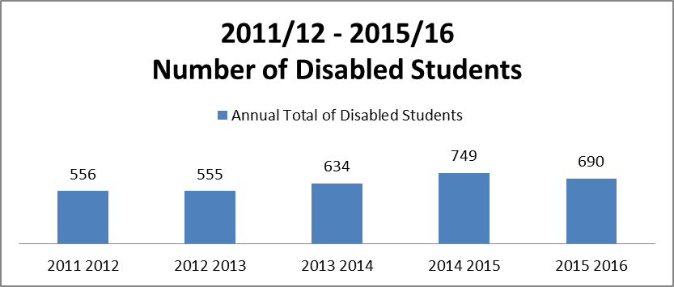
A wide range of support is provided in response to disabled students’ needs, including: Individual Learning Plans, Disabled Student Allowance (DSA) Needs Assistance, access to medical or psychological evidence from professional/clinical experts; assistance with DSA application/re-application; support in arranging DSA equipment from suppliers or DSA non-medical personal help; provision of assistive technology training; equipment loan, referral or signposting to other student services; and help to source non-medical personal help or consumables where not DSA supported. Equipment available includes laptops installed with assistive software eg Texthelp ReadandWrite GOLD, Mindmanager, SSOverlay and Audionotetaker; multifunctional devices, digital voice recorders, and ergonomic items.
.
Figure 2 Number of DSA applications
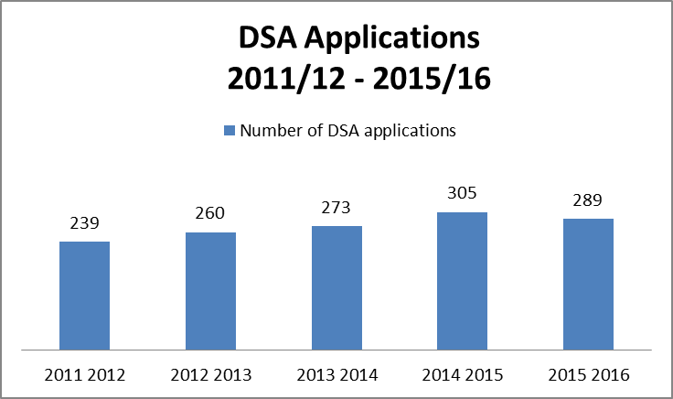
In the period to July 2016, 333 students were eligible for DSA support, of which 289 applied.

The Disability Service was revalidated by the Scottish Government Disabled Students Advisory Group (DSAG) Revalidation Panel in September 2015, which means that the University continues to directly assess students with Specific Learning Difficulties, Mental Health Difficulties and with Autistic Spectrum Conditions.

The Disability Service surveys undergraduate and postgraduate service users annually. For the 2016 survey, 68 students drawn from across all years of study responded. Fifty-eight respondents were female and 10 male, and 58 were Scottish and 10 from the EU. Forty-five reported that they had first contacted the Disability Service either prior to attending QMU or within the first semester of their first year of study. Overall, 55 respondents considered that the Disability Service was very helpful and supportive or helpful.

In February 2016, the QMU Disability Service undertook a Service Review, with key areas of focus being:

- identification of core services, and consideration of the balance between in-house and outsourced resources,
- process review and identification of streamlining;
- governance of the Needs Assessment Centre;
- team members’ roles, responsibilities and allocation of tasks;
- benchmarking and good practice against a comparable Disability Service in a similar sized University.

The review panel included a senior Head of Service from another Scottish University.

A number of process improvements were identified, including pre Admissions contact by applicants; streamlining of Individual Learning Plans; development of Service Level Agreements with relevant service providers; monitoring of DSA Needs Assessment Reports; formalisation of appointment making for all aspects of the Disability Service; centralisation of data recording on the Student Records system; and outsourcing of External Tutor Team related activities.

Most of these were achieved in 2015/16, with a small number coming to completion by the end of 2017.

The development of an Inclusive Practice Policy, and related policies, was recommended, and a draft was presented to the Student Experience Committee in April 2017. Further consultation on the adoption and implementation of the specific actions in that policy will take place through School Academic Boards in the remainder of the academic session to July 2017.

In February 2017, the University appointed a permanent full-time Wellbeing Adviser, who will develop a series of initiatives to support students whether identified with a disability or not. The Adviser will also undertake mental health mentoring, so this will no longer be outsourced.

The Student Mental Health and Wellbeing Steering Group produced a student mental health and wellbeing policy in 2016. The University and the Students’ Union continued to collaborate to promote and support positive mental wellbeing with a range of initiatives over the year. A three year action plan has been set by the group to support the implementation of the policy. Activities range from an awareness campaign, to workshops and training sessions. The steering group acknowledges the importance of equipping staff with the required skills to support and signpost students; training and guidance are being provided to both professional and academic staff.

Each year, the University runs a number of student experience surveys on the teaching and learning experience. These are aimed at different levels of study and students are only eligible to complete one.

The National Student Survey (NSS), for final year undergraduate students, is administered by Ipsos MORI. Results for some protected characteristic groups are provided to the University. Results under Disability are split into students with a learning difficulty and students with any other disability. The University also runs the QMU Student Survey (QSS) using the same questions as the NSS, but this survey is aimed at all other taught students (first to third year and taught postgraduates). All analysis is carried out internally and split by postgraduate and undergraduate students. Group analysis includes some protected characteristic and socio-economic groups. Students with a declared disability are considered as one group in the analysis.

Survey results are considered by most institutional committees and some have a specific responsibility for responding to the results. Group analysis from surveys is considered by the WISeR Board and the Equality and Diversity Committee. School Academic Boards approve and monitor the School NSS action plans. Survey results are also made available to all staff through a dedicated intranet site. From 2016/17, students are able to access a summary of results from each of the main institutional surveys on a Hub site. This includes commentary on key results from group analysis.

Results from the NSS and the QSS have highlighted some differences in the learning and teaching experience of disabled students across different levels of study and for those with a specific learning disability compared to those with other disabilities. NSS results for the past two years show that disabled students with a learning difficulty are less satisfied than their peers. Conversely, students with any other disability are the most satisfied group. These results differ from the rest of the sector where there is much less of a difference between the two groups and students without a disability. QMU students with a learning difficulty are also less satisfied than their peers in the UK, while QMU students with another disability were much more satisfied than their peers in the sector. Areas of dissatisfaction were Academic Support, the timetable, learning resources, and the Students’ Union.

Results from the QMU Student Survey in 2016 showed that disabled undergraduate students are more satisfied overall than their peers following an increase in satisfaction in ‘teaching on my course’ and Personal Development, as well as a substantial increase of 12% in overall satisfaction. Disabled taught postgraduates are also more satisfied overall and with Teaching on their course, Learning Resources and Personal Development. However, they are much less satisfied then their peers without a disability with Assessment & Feedback, Organisation and Management.

This outcomes set out above require further investigation and form the basis of Equality Outcome 4 for the period to 2021.

Outcome 6: Ensure students meet employers’ requirements.

Our Strategic Plan suggests that, ‘through our portfolio of socially and economically relevant educational programmes, we will continue to develop graduates and postgraduates who are able to think independently, reflectively and creatively, who are ready for employment, and who have an enthusiasm for lifelong learning.’

At the time of publication of this report (April 2017) our Higher Education Statistics Agency (HESA) PI for employability (based on 2014/15 data) is 91.9%. We believe that data for 2015/16 will demonstrate an improved position, and demonstrate clearly that we are producing graduates that meet employers’ requirements.

Our refreshed Employability Strategy, originally launched in August 2014, brings together in a single document our approach to employability, with the primary objective of providing equitable employment and careers education to all student and graduates. The strategy is a public statement to our students, staff, partners and employers of our commitment to the success of our students and how we will support this across the institution. It provides focus, drive and resources for the support of students and graduates, further connecting their studies with their future employment and life opportunities, enabling successful transitions.

Key objectives during the lifetime of this Mainstreaming Report (2017-21) include:

• To enable a parity of provision of employability and careers education to all students and graduates.
• To review, prioritise and promote the University’s Graduate Attributes.
• To increase the appropriate use of work-based and work-related learning, seeking to include a placement/appropriate industry partners for every programme, encouraging self-reflection and personal development planning at all levels.
• To embed the culture of mentoring across the University, promoting mentoring with peers, Personal Academic Tutors, employers and entrepreneurs.
• To increase participation of students in university committees, internships, volunteering, overseas study exchanges and sports and societies, expanding students’ sports groups and societies, including discipline-based societies.
• To recognise active participation of students in co- and extra-curricular activities through appropriate award schemes.
• To support students and graduates in developing a positive mind-set, resilience and self-management.

Over the period 2015-17, our Employer Mentoring Project has provided employability mentoring to specific groups of students for whom statistics show that it can be difficult to find graduate employment. The programme gives committed and enthusiastic students the opportunity to meet with an experienced individual from a relevant sector, who is willing to offer their time, advice and inside knowledge surrounding the world of work. Priority is given to undergraduate Scottish domiciled male, BME, mature, direct entrant or disabled students. However based on feedback the criteria are not advertised to avoid stigmatisation of the programme and the participant students.

The overall objective of the programme is to nurture a mentoring culture at the university, where senior students mentor junior students. The programme’s goal is to increase confidence in participant students, prepare students for the world of work and to create for them links and job opportunities. The growth and success of the scheme attracted an invitation to showcase it as a widening access project at the EPIC conference in Bratislava in 2016. The project was awarded the Education Project of the Year in the 2017 Scottish Mentoring Awards. Mentoring is now incorporated firmly in our Employability Strategy.

Outcome 7: Increase awareness of hate crime and decrease tolerance of this crime.

The University promotes good relations between different protected characteristics through a number of awareness raising initiatives. Over the life-time of this Outcome, these have focused largely on disability and gender eg Disability Awareness Week, International Women’s Day and Mental Health Week. Most recently we have participated actively in Scotland Welcomes the World, as part of our commitment to promoting our diverse and inclusive environment which welcomes and celebrates different people and cultures from around the world.

We are committed to fostering an environment in which all students and staff, regardless of their background and personal circumstances are treated with dignity, respect and fairness. We recognise that any form of harassment has a serious detrimental effect on the confidence, morale, performance and health of individuals. In May 2016, our commitment to students was codified within the Student Anti-bullying and Harassment policy. The preamble to the policy states clearly that harassment, bullying or victimisation will not be tolerated in any form. This policy is in addition to our Student Disciplinary procedure, which sets out clearly that harassment or victimisation on the grounds of any protected characteristic is a disciplinary offence.

We have not had any allegations of hate crime in relation to students under either policy.

Outcome 9: Embed equality and diversity in the curriculum and in research.

We believe that the University’s Quality Assurance and Enhancement processes represent an area of good practice in mainstreaming. This includes the validation and review of new and established programmes, and the annual monitoring of all programmes.

During the validation and review process, the checklist for approval panels explicitly invites panel members to consider whether there is:

• sufficient evidence that the Programme will contribute to widening access and engaging students from non-traditional backgrounds and under-represented groups
• sufficient evidence of curriculum innovation and development to enhance equality and diversity, as well as to address potential exclusionary aspects of the programme and to encourage students to think globally and locally
• evidence of inclusive teaching practices.

It is recognised that the learning from the answers to these questions could be more widely shared to promote further inclusivity good practice across the University.

In terms of embedding equality in research and research practices, the University has:

• Continued to enhance gender equality initiatives beyond the traditional STEM domain of Athena SWAN to promote initiatives such as the Stonewall Equality Index and to participate in the Aurora programme.
• Publicised and implemented the QMU REF Equality Code of Practice.
• Committed to act on the feedback and comments from the HEFCE Equality and Diversity Panel.
• Secured the Athena SWAN Bronze award, and is now working towards maintaining that award and to obtaining a Silver award.
• Implemented the Vitae Researcher Development Framework and Planner with a section on Equality and Diversity in Research Careers.
• Actively participated in Vitae’s Every Researcher Counts Project
• Introduced Maternity coaching to support researchers in their careers pre and post maternity leave.
• Put in place campus based “inspiring women case studies” to showcase positive female role models across a range of positions within the workplace.

Outcomes 10 and 11

Demonstrate our commitment to advancing women's careers in STEM subjects via Athena
SWAN/Increased equality and diversity in research careers.

Our strong commitment to equality in research is promoted in a number of different ways, including through the HR Excellence Award for Researcher Career Development and further Athena SWAN recognition.

In terms of research, the University received very positive feedback on the staff profile of its REF submission and the wide integration of staff with complex and special circumstances. The number of staff eligible for submission in these categories was significantly above sector averages. QMU has committed to act on the feedback and comments from the HEFCE Equality and Diversity Panel in preparing for REF 2021.

We will continue to benchmark our research activity in relation to sector UoA norms for tariff reductions, return of early career researchers and other key data. We are committed to championing gender equality initiatives through continuing to maintain our Athena SWAN accreditation at a divisional and wider university level and drive our aligned Athena SWAN actions through quarterly steering group meetings.

The University was one of the first of ten UK institutions to retain the HR Excellence Award for Researcher Careers. Among the criteria for the award, and its retention, is the ability to demonstrate that rewards and other terms and conditions of service for contract research staff (for example, rates of pay, provisions for leave and sick leave, pensions, access to facilities) are in line with those for established staff. There needs to be assurance also of equal opportunities and the elimination of practices linked to the short-term nature of contracts which indirectly discriminate against women.

Outcome 12: Increase the representation of males in health sciences.

When we established this outcome, we recognised the preponderance of female students studying programmes in our School of Health Sciences, and the impact of this on our overall student population. This reflects the national picture. Benchmark statistics published by the Scottish Funding Council on 30 March 2017, ‘Higher Education Students and Qualifiers at Scottish Institutions 2015-16’, record that male entrants made up just 17% of entrants to Allied Health degrees in 2015-16. Females accounted for 58.0% of the students at HEIs in 2015-16. The subject groups with the highest proportions of female entrants were subjects allied to Medicine (83.0%), Veterinary Science (79.7%) and Psychology (76.2%).

We have recently revised this outcome to focus on the enrolment of mature and younger male applicants to Nursing and to Psychology. Both of these subject areas have been identified as having a severe gender imbalance within the University under the definition adopted by the SFC. QMU has a very similar percentage of males to females to the national picture (differences of 1%). The data on mature students show that the gender split is far less pronounced, and the conversion rates are much higher, which may be evidence of the work QMU staff have undertaken with applicants entering QMU through alternative routes. The data show that although conversion rates were up on previous years for males, there were still not enough males applying to plug the gap in the gender split. The focus during 2017 has been on outreach work with Schools and Colleges.

We were delighted to have been successful in a bid for support from the Equality Challenge Unit (ECU) to assist us in developing an approach to this outcome. Specifically, we are working with the ECU as part of its Attracting Diversity project to identify positive steps to mitigate against any barriers to access for these groups. Our aim is to increase application, offer and enrolment numbers from mature male applicants and younger male applicants to Psychology & Nursing programmes. During 2016, the project evaluated data, held Focus Groups with males in Nursing and Psychology, laid out clear progression routes and formal articulations with Colleges and investigated early intervention activities with a focus on gender throughout the learner journey. This work will provide the basis for an action plan from 2017 onwards. The objective for 2017 is for teams within the project to use the evidence and activities gleaned in 2016 to develop and trial a pilot ‘attracting diversity’ initiative.

SECTION 3 - OUTCOMES 2017-20
We are committed to the following Outcomes during the period 2017-21. A number of outcomes established for the period 2014-17 have been retained on the basis that they represent long-term commitments.

Equality Outcome 1: The University workforce represents the community it serves.

Equality Outcome 2: Pay Gaps are eliminated where the pay gap is significant in statistical terms.

Equality Outcome 3: Recruitment, progression, retention and attainment of students drawn from a wide range of backgrounds is maximised.

Equality Outcome 4: Our people policies promote inclusive employment and career advancement prospects.

Equality Outcome 5: The particular needs of disabled staff and students are fully accommodated.

Equality Outcome 6: Equality and diversity is embedded fully in the curriculum and in research.

Equality Outcome 7: Women's careers in research and in STEM subjects are advanced through Athena SWAN and other sector initiatives.

Outcome | Evidence Base | Possible activities/Outputs | PC(s) and general duty | Responsibility
Equality Outcome 1  Ensure that the workforce of the University represents the community it serves  We will adopt a broad definition of ‘workforce’ to include non-executive directors on our Governing Body, and those with whom we engage in partnership in the delivery of the student learning experience. | Internal HR management information;  HESA Staff return;  Capita Staff Survey Output;  Outcome Agreement Evaluation;  Annual Report and Accounts;  Court Annual Review;  Externally facilitated Court Review (due 2019). | - Promote equality and diversity in recruitment and reward of staff and in consideration of job descriptions.  - Ensure all committees and decision making bodies of the University are representative of its community.  - Maintenance of agreed %age Gender Balance on the University Court and its standing committees, and achievement of gender balance on key decision making bodies of the University, including staff recruitment and reward and recognition panels.  - Development and Publication of a Gender Action plan in line with SFC guidance.  - Further improvement in the collection of staff data by protected characteristics.  - An improvement in the percentage of those staff who declare a protected characteristic in the next Staff Survey.  We will continue to work with the Equality Challenge Unit on the development of effective policies and interventions to achieve this outcome.  We will complete our audit of all formal University policy statements/regulations, with a view to producing a definitive register which sets out: policy owner, date of approval/last review and date of EIA. | Age, Disability, Gender identity, Race, Gender, Sexual orientation, Pregnancy and maternity, Faith and belief.  Eliminate unlawful discrimination, foster good relations and advance equality of opportunity. | Head of Human Resources  University Secretary
Equality Outcome 2:  Pay Gaps are eliminated where the gap is statistically significant.  The University will take action to remove any statistically significant pay gap in favour of any group. | Equal Pay Review  Internal Management Information;  HESA Staff return. | Actions listed under Outcomes 1, 4, 5, 6, 7 apply. | Age, Disability, Gender identity, Race, Gender, Sexual orientation, Pregnancy and maternity,  Eliminate unlawful discrimination, foster good relations and advance equality of opportunity. | Head of Human Resources
Equality Outcome 3  Recruitment, admission, progression, retention and attainment of students drawn from a wide range of backgrounds is maximised.  Representation of learners from different protected characteristic groups of Scottish domiciled undergraduate students is maintained to at least the levels set out below over a three year rolling period.  - Disabled students at 12%.  - Students from BME ethnic background at 6%.  - Mature students at 25%.  Increased percentage of full-time first year Scottish domiciled undergraduate entrants returning to study in year two from a baseline of 90% in 2015/16 to 93% in 2019-20:  - 91% in 2017-18  - 92% in 2018-19  - 93%in 2019-20  To achieve at least 92% returning to year two rate by 2016-17 for identified OA groups of full-time Scottish domiciled entrants, including disabled, SIMD20, SIMD40, Male, BME, Care Experienced, Mature and Direct Entrants:  - 90% in 2017-2018  - 91% in 2018-2019  - 92% in 2019-2020 | HESA Student Return;  Outcome Agreement Data Group monthly analysis;  Annual Report data analysis;  NSS data analysis;  Outcome Agreement Annual Evaluation Report;  ELIR 4 judgement 2018. | Actions set out in the University Outcome Agreement 2017-20 will be implemented fully.  In terms of recruitment and admission, these include: participation in, and response to, collaborative initiatives developed through the 3 CoWA work streams; Intensified outreach work; further review of contextual admissions policy, to include consideration of differential offers; enhanced conversion activity including bursary support to target students; monitoring of data on applications, offers and conversion rates for candidates from those groups identified as having targeted intake in our Outcome Agreement; further embedding of support arrangements targeted on those students from the most deprived postcodes; prioritising of those schools with the lowest HE progression rates; collaboration with communities to de-mystify higher education and to empower individuals seeking to access higher education.  In terms of retention, develop, promote and review strategies to maximise student retention and progression  Actions set out in the Student Mental Health and Wellbeing Action Plan will be implemented fully.  Actions set out in School Operational Plans will be implemented fully. | Age, Disability, Gender identity, Race, Gender, Sexual orientation, Pregnancy and maternity,  Eliminate unlawful discrimination, foster good relations and advance equality of opportunity. | Deans of School;  University Secretary;  Assistant Secretary, ELSS;  Student Retention and Surveys Team;  Outreach and Community Engagement Team.
Equality Outcome 4  Our people policies promote inclusive employment and career advancement prospects. | Staff Survey results;  HR Management Information . | - Raise awareness of HR policies amongst all staff.  - Continue to consult with key stakeholders over the revision of existing and the development of new policies and on the potential equalities impacts  - Continue to develop and revise HR policies based on best practice and legislative changes taking into account all of the protected characteristics.  - Progress fully all actions set out in the institutional Athena Swan Action Plan.  - Raise awareness of issues relating to occupational segregation and gender pay gaps.  - Promote E-learning Unconscious Bias training to all managers and recruitment and selection panellists.  - Actively seek opportunities for increasing staff diversity through recruitment and selection, for example, by highlighting flexible working at the point of recruitment, reviewing job titles and advert wording to address potential occupational stereotyping.  We will continue to work with the Equality Challenge Unit on the development of effective policies and interventions to achieve this outcome. We will complete our audit of all formal University policy statements/regulations, with a view to producing a definitive register which sets out: policy owner, date of approval/last review and date of EIA. | Age, Disability, Gender identity, Race, Gender, Sexual orientation, Pregnancy and maternity, Faith and belief;  Advancing equality of opportunity and eliminating unlawful discrimination. | Head of Human Resources
Equality Outcome 5  The particular needs of disabled staff and students are fully accommodated. | Staff Survey results;  HR Management Information;  HESA Student Return;  Outcome Agreement Data Group monthly analysis;  Annual Report data analysis;  NSS data analysis;  Outcome Agreement Annual Evaluation Report;  ELIR 4 judgement 2018. | - Put in place actions arising from the 2016 review of the Disability Service.  - As a ‘Disability Confident’ accredited employer, implement core actions and activities to support disabled people under the themes: ‘Getting the right people for your business’ and ‘Keeping and developing your people’.  - Contribute to the development of the British Sign Language (BSL) National Plan, as far as we are able, and put in a place an action plan to address our responsibilities under the British Sign Language Act requirements,  - In terms of National Student Survey outcomes 2016, continue to investigate reasons for lower satisfaction rates of students with a Specific Learning Difficulty, compared to other students declaring a disability.  - In implementing the Student Mental Health and Wellbeing Policy, and as per the Equality Act 2010, recognise mental ill health as a disability and provide adequate support to students with declared mental ill health. | Age, Disability, Gender identity, Race, Gender, Sexual orientation, Pregnancy and maternity,  Eliminate unlawful discrimination, foster good relations and advance equality of opportunity. | Head of HR  Head of Student Services  Director of Campus and Commercial Services.
Equality Outcome 6  Equality and diversity is embedded fully in the curriculum and in research. | Athena SWAN award/s; Membership and Participation in the Edinburgh Beltane  REF 2021  ELIR 4 judgement 2018  Outcomes.  REF 2021 Equality Code of Practice.  Athena SWAN  HR Excellence Award | - Publication of action arising from the Disability Service Review 2016 to include approval of updated Inclusive Learning and Teaching policy.  - Continued good practice represented by existing Validation and Accreditation process.  - Conduct Internal Audit of REF preparations.  - Continue to enhance gender equality initiatives beyond the traditional STEM domain of Athena SWAN through initiatives such as the Stonewall Equality Index and the Aurora programme.  - Implement QMU REF Equality Code of Practice.  - Progress action arising from HEFCE Equality and Diversity Panel.  - In preparation for REF 2021, invite staff to participate in a focus group, facilitated by ECU, to better understand the potential barriers to research for staff with protected characteristics  - Maintain Athena SWAN Bronze award, and achieve Silver award.  - Continue to implement Vitae Researcher Development Framework and actively participate in Vitae’s Every Researcher Counts Project.  - Provide maternity coaching to support researchers in their careers pre and post maternity leave.  - Continue to promote campus based “inspiring women case studies” to showcase positive female role models across a range of positions within the workplace. | Age, Disability, Gender identity, Race, Gender, Sexual orientation, Pregnancy and maternity,  Eliminate unlawful discrimination, foster good relations and advance equality of opportunity. | Deputy Principal/University Secretary/Deans of School
Equality Outcome 7  Women’s careers in research and in STEM subjects will be advanced through Athena SWAN and other sector initiatives. | REF 2021 Outcomes;  REF 2021 Equality Code of Practice;  Athena SWAN recognition;  HR Excellence Award. | - Internal Audit of REF preparations.  - Continued to enhance gender equality initiatives beyond the traditional STEM domain of Athena SWAN through initiatives such as the Stonewall Equality Index and the Aurora programme.  - Implement QMU REF Equality Code of Practice.  - Progress action arising from HEFCE Equality and Diversity Panel.  - Maintain Athena SWAN Bronze award, and achieve Silver award.  - Continue to implement Vitae Researcher Development Framework and Actively participate in Vitae’s Every Researcher Counts Project  - Provide maternity coaching to support researchers in their careers pre and post maternity leave.  - Continue to promote campus based “inspiring women case studies” to showcase positive female role models across a range of positions within the workplace. | Age, Disability, Gender identity, Race, Gender, Sexual orientation, Pregnancy and maternity,  Eliminate unlawful discrimination, foster good relations and advance equality of opportunity. | Deputy Principal/Deans of School  Research Centre Directors.

SECTION 4: EMPLOYMENT INFORMATION

Information relating to staff employed by the University is set out in the documents attached as Appendices 1 and 2 of this report.

SECTION 5: RESOURCES

Evidence Base

- Management Information and Analytical Reports considered by the Equality and Diversity Committee during the period 2015-2017.
- Consultation with the Students’ Union and the WISeR Board.
- HESA Staff return 2015-16.
- HESA Student return 2015-16.
- Internal Management Information drawn from the Tribal Student Records system (April 2017).
- Internal Management Information drawn from the i-Trent HR Records system (April 2017).
- Capita Staff Survey Return 2015 and resulting internal analysis.
- WISeR Board Student Retention Statistics.
- Outcome Agreement Evaluation 2016.
- EHRC Essential guide to the Public Sector Equality Duty: A guide for public authorities in Scotland, published October 2016.
- Equality in higher education: students statistical report 2016, Equality Challenge Unit;
www.ecu.ac.uk/wp-content/uploads/2016/11/ECU_students16.xlsx
- Equality in higher education: staff statistical report 2016, Equality Challenge Unit: www.ecu.ac.uk/wp-content/uploads/2016/11/ECU_staff16.xlsx
- Higher Education Students and Qualifiers at Scottish Institutions 2015-16: Statistical publication SFC/ST/06/2017, published 30/03/2017
http://www.sfc.ac.uk/communications/Statisticalpublications/2017/SFCST062017.aspx
- QMU Outcome Agreement Data Management Group data (established 2016).
- ECU and EHRC tool kits have been particularly helpful in drawing together this report.

The following have provided insight at conferences and meetings:

All other Scottish Universities and in particular, E&D colleagues
Equality Challenge Unit Scotland

SECTION 6 – MANAGEMENT INFORMATION – STUDENT POPULATION HEAD COUNT (EXCLUDING BASED OVERSEAS IN COLLABORATIVE PARTNERSHIP ORGANISATIONS)

GENDER | 2012/3 |  | 2013/4 |  | 2014/5 |  | 2015/6 |  | 2016/7
Female | 3667 | 76.0% | 3666 | 75.4% | 3722 | 75.0% | 3669 | 75.5% | 3630 | 76.1%
Male | 1156 | 24.0% | 1195 | 24.6% | 1238 | 24.9% | 1190 | 24.5% | 1138 | 23.8%
Other Gender | 1 | 0.0% | 1 | 0.0% | 2 | 0.0% | 2 | 0.0% | 5 | 0.1%
Gender not known | 0 | 0% | 0 | 0% | 0 | 0% | 0 | 0% | 0 | 0%
 | 4824 |  | 4862 |  | 4962 |  | 4861 |  | 4773
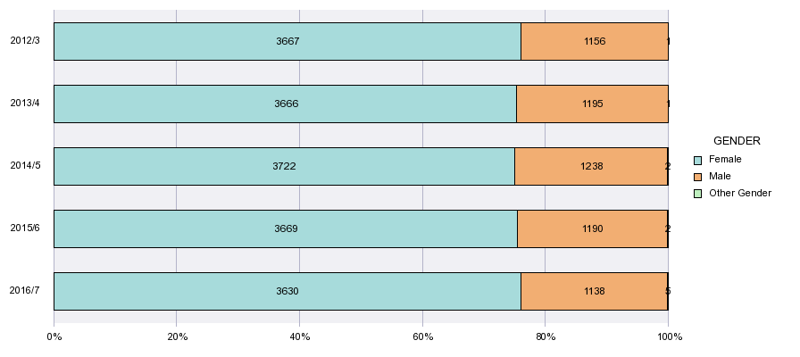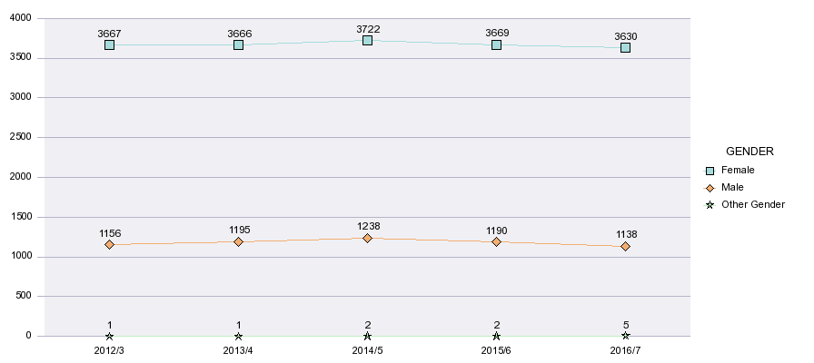

DISABILITY | 2012/3 |  | 2013/4 |  | 2014/5 |  | 2015/6 |  | 2016/7
DISABILITY DECLARED | 625 | 13.0% | 663 | 13.6% | 704 | 14.2% | 646 | 13.3% | 616 | 12.9%
NO DISABILITY | 4183 | 86.7% | 4183 | 86.0% | 4244 | 85.5% | 4210 | 86.6% | 4152 | 87.0%
INFO REFUSED | 7 | 0.1% | 2 | 0.0% | 1 | 0.0% | 2 | 0.0% | 5 | 0.1%
UNKNOWN | 9 | 0.2% | 14 | 0.3% | 13 | 0.3% | 3 | 0.1% | 0 | 0%
 | 4824 |  | 4862 |  | 4962 |  | 4861 |  | 4773
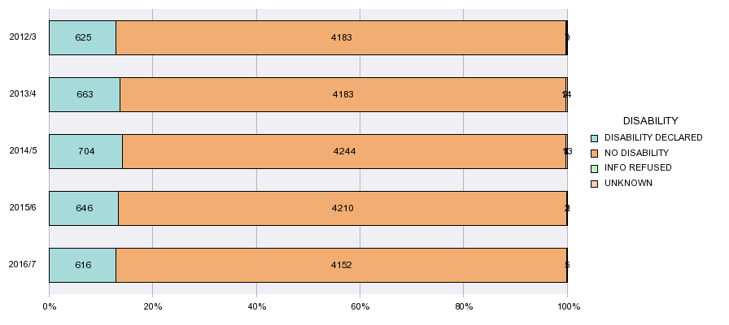
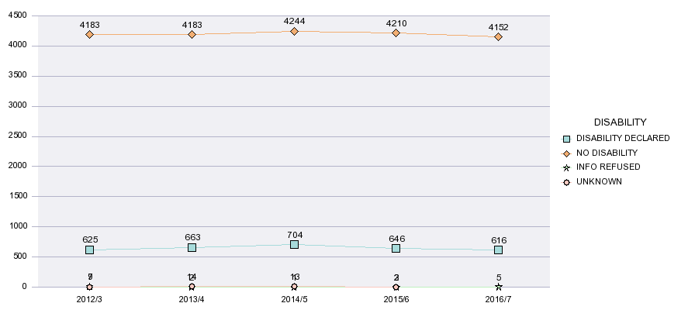

ETHNICITY | 2012/3 |  | 2013/4 |  | 2014/5 |  | 2015/6 |  | 2016/7
BME | 608 | 12.6% | 580 | 11.9% | 568 | 11.4% | 562 | 11.6% | 520 | 10.9%
White | 4070 | 84.4% | 4179 | 86.0% | 4306 | 86.8% | 4235 | 87.1% | 4205 | 88.1%
Information Refused | 109 | 2.3% | 73 | 1.5% | 61 | 1.2% | 44 | 0.9% | 44 | 0.9%
Not Known | 37 | 0.8% | 30 | 0.6% | 27 | 0.5% | 20 | 0.4% | 4 | 0.1%
 | 4824 |  | 4862 |  | 4962 |  | 4861 |  | 4773
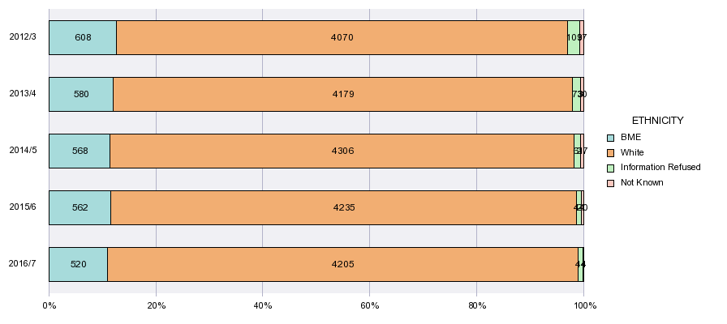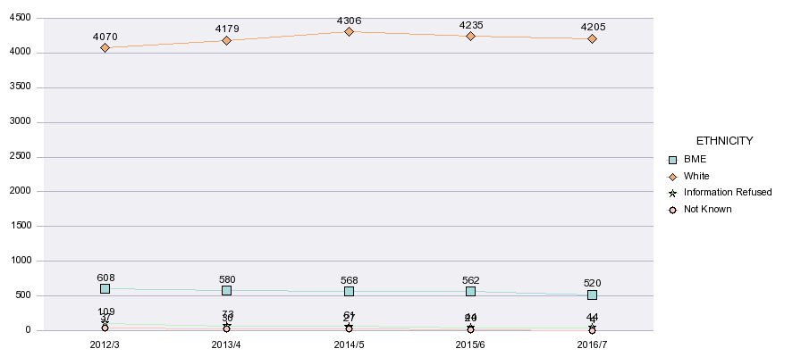

RELIGIOUS BELIEF | 2012/3 |  | 2013/4 |  | 2014/5 |  | 2015/6 |  | 2016/7
Any other religion or belief | 25 | 0.5% | 32 | 0.7% | 41 | 0.8% | 45 | 0.9% | 42 | 0.9%
Buddhist | 21 | 0.4% | 20 | 0.4% | 18 | 0.4% | 21 | 0.4% | 17 | 0.4%
Christian | 1 | 0.0% | 1 | 0.0% | 0 | 0% | 0 | 0% | 2 | 0.0%
Christian - Catholic | 397 | 8.2% | 521 | 10.7% | 584 | 11.8% | 583 | 12.0% | 612 | 12.8%
Christian - Church of Scotland | 295 | 6.1% | 369 | 7.6% | 393 | 7.9% | 374 | 7.7% | 311 | 6.5%
Christian - Other denomination | 348 | 7.2% | 402 | 8.3% | 414 | 8.3% | 415 | 8.5% | 382 | 8.0%
Hindu | 27 | 0.6% | 26 | 0.5% | 41 | 0.8% | 33 | 0.7% | 22 | 0.5%
Jewish | 7 | 0.1% | 7 | 0.1% | 8 | 0.2% | 10 | 0.2% | 10 | 0.2%
Muslim | 101 | 2.1% | 122 | 2.5% | 130 | 2.6% | 132 | 2.7% | 125 | 2.6%
No religious belief | 1081 | 22.4% | 1433 | 29.5% | 1708 | 34.4% | 1888 | 38.8% | 2026 | 42.4%
Sikh | 3 | 0.1% | 3 | 0.1% | 4 | 0.1% | 5 | 0.1% | 6 | 0.1%
Spiritual | 32 | 0.7% | 36 | 0.7% | 35 | 0.7% | 47 | 1.0% | 48 | 1.0%
Information refused | 72 | 1.5% | 118 | 2.4% | 121 | 2.4% | 144 | 3.0% | 137 | 2.9%
Not known | 2414 | 50.0% | 1772 | 36.4% | 1465 | 29.5% | 1164 | 23.9% | 1033 | 21.6%
 | 4824 |  | 4862 |  | 4962 |  | 4861 |  | 4773
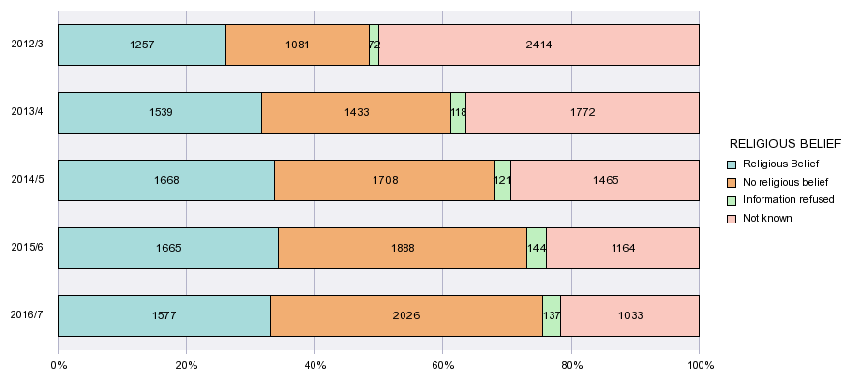
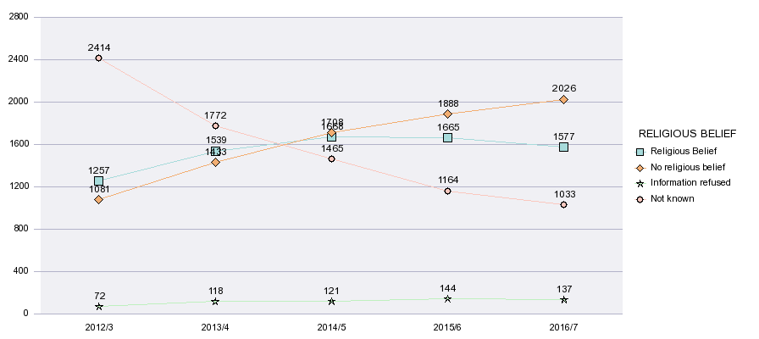

SEXUAL ORIENTATION | 2012/3 |  | 2013/4 |  | 2014/5 |  | 2015/6 |  | 2016/7
Bisexual | 33 | 0.7% | 48 | 1.0% | 65 | 1.3% | 86 | 1.8% | 114 | 2.4%
Gay man | 49 | 1.0% | 63 | 1.3% | 74 | 1.5% | 79 | 1.6% | 64 | 1.3%
Gay woman/lesbian | 24 | 0.5% | 26 | 0.5% | 24 | 0.5% | 28 | 0.6% | 30 | 0.6%
Heterosexual | 1947 | 40.4% | 2528 | 52.0% | 2926 | 59.0% | 3195 | 65.7% | 3279 | 68.7%
Other | 41 | 0.8% | 50 | 1.0% | 58 | 1.2% | 50 | 1.0% | 52 | 1.1%
Information refused | 112 | 2.3% | 140 | 2.9% | 165 | 3.3% | 177 | 3.6% | 179 | 3.8%
Not known | 2618 | 54.3% | 2007 | 41.3% | 1650 | 33.3% | 1246 | 25.6% | 1055 | 22.1%
 | 4824 |  | 4862 |  | 4962 |  | 4861 |  | 4773
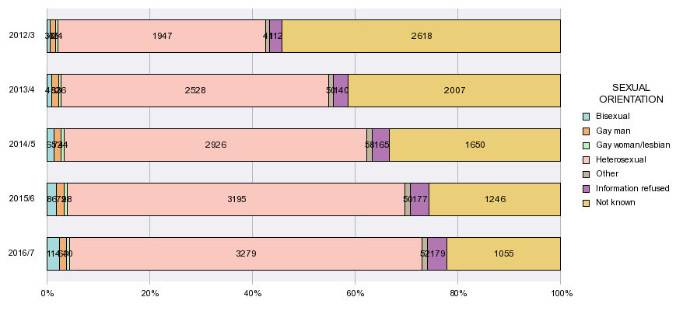
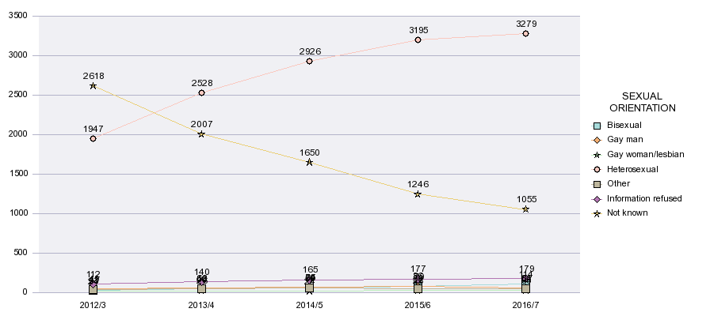

GENDER IDENTITY | 2012/3 |  | 2013/4 |  | 2014/5 |  | 2015/6 |  | 2016/7
Gender identity different from gender assigned at birth | 12 | 0.2% | 15 | 0.3% | 18 | 0.4% | 45 | 0.9% | 41 | 0.9%
Gender identity same as gender assigned at birth | 2430 | 50.4% | 3096 | 63.7% | 3531 | 71.2% | 3690 | 75.9% | 3668 | 76.8%
Information refused | 28 | 0.6% | 43 | 0.9% | 47 | 0.9% | 51 | 1.0% | 53 | 1.1%
Not known | 2354 | 48.8% | 1708 | 35.1% | 1366 | 27.5% | 1075 | 22.1% | 1011 | 21.2%
 | 4824 |  | 4862 |  | 4962 |  | 4861 |  | 4773
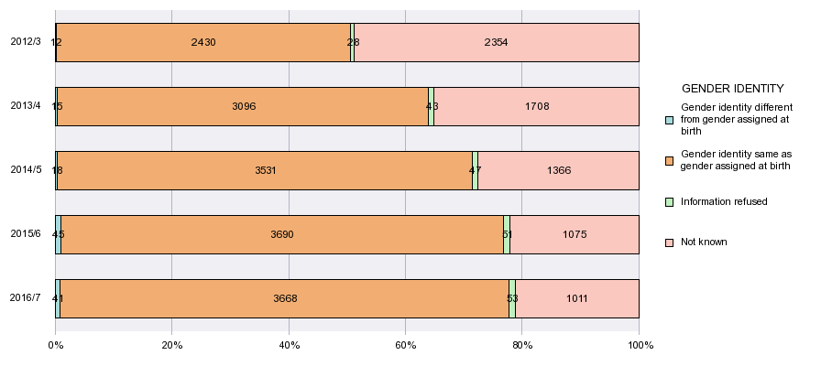
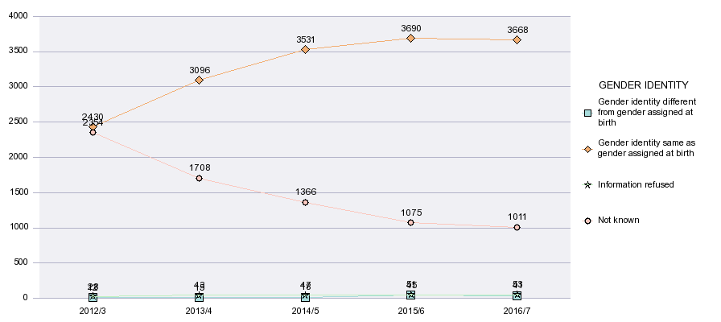

MARITAL STATUS | 2012/3 |  | 2013/4 |  | 2014/5 |  | 2015/6 |  | 2016/7
Co-habiting | 190 | 3.9% | 216 | 4.4% | 217 | 4.4% | 245 | 5.0% | 254 | 5.3%
Divorced or civil partnership dissolved | 72 | 1.5% | 78 | 1.6% | 87 | 1.8% | 75 | 1.5% | 60 | 1.3%
Married or in civil partnership | 760 | 15.8% | 787 | 16.2% | 767 | 15.5% | 729 | 15.0% | 679 | 14.2%
Separated (but still legally married or in CP) | 39 | 0.8% | 44 | 0.9% | 40 | 0.8% | 41 | 0.8% | 35 | 0.7%
Single (never married or never in CP) | 2794 | 57.9% | 2897 | 59.6% | 3067 | 61.8% | 3003 | 61.8% | 2967 | 62.2%
Widowed or a surviving partner from a CP | 6 | 0.1% | 10 | 0.2% | 7 | 0.1% | 6 | 0.1% | 4 | 0.1%
Not known | 963 | 20.0% | 830 | 17.1% | 777 | 15.7% | 762 | 15.7% | 774 | 16.2%
 | 4824 |  | 4862 |  | 4962 |  | 4861 |  | 4773
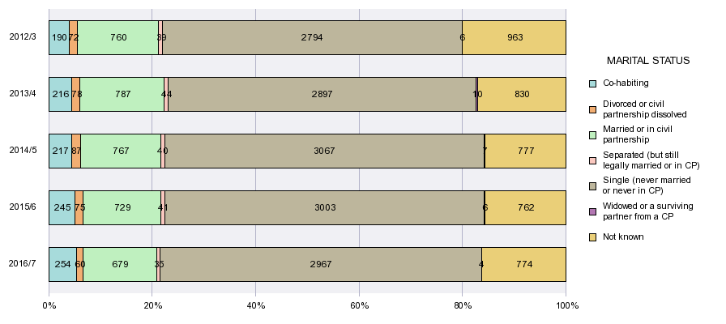
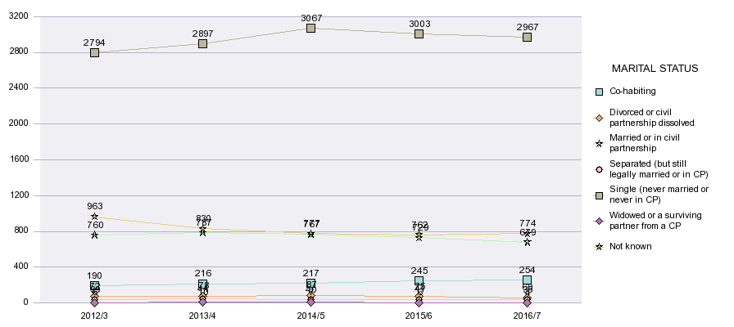

APPENDICES

Associated Reviewed Employment Information

Appendix 1 Staff Equalities Data April 2017
Appendix 2 Equal Pay Review April 2017

http://www.ecu.ac.uk/guidance-resources/governance-and-policies/governing-bodies/

