The course rollover process will create and set-up a folder on the Panopto for the next years module, but the content of the folder will not be copied over.
Links that were created on content areas on the previous year’s module will roll over and be accessible to students on the new module. Embedded videos and links to Panopto videos that are part of the content are will rollover and be accessible.

If your module allowed students to access the Panopto videos only from the left menu, rather than from links in a content area, then you will need to follow Option 1 below to share the folder from the previous module. If you only wish to copy individual videos over then follow Option 2 below.

Option 1: Share all videos from another Panopto folder

Go to the Hub module and select Lecture recording (Panopto) link on the left menu
Scroll to the bottom of the page and click on Re-Configure
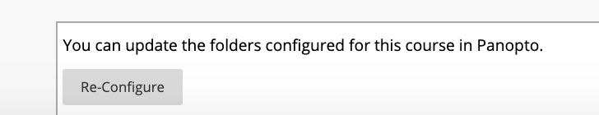

Scroll down the Available Folders list and select the folder for the module you wish to share the videos from then click on the Add button to move it to the Selected Folders area.
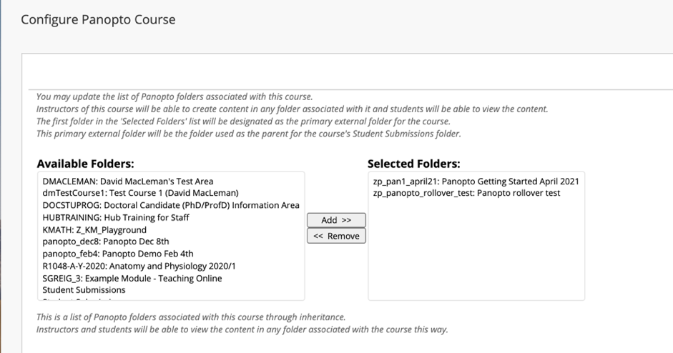

The Content area will show the shared videos and the source folder. Any videos created in this module will show in the folder for this module.
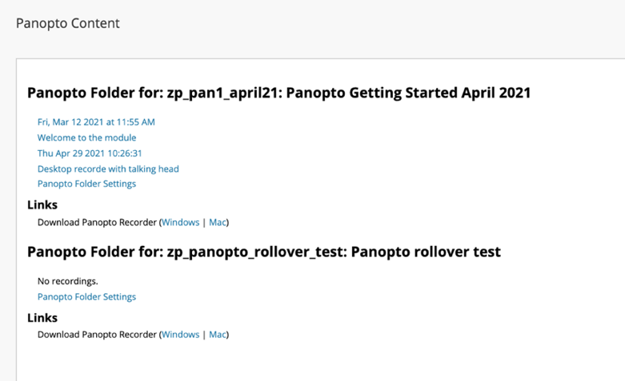

Option 2: Copy individual videos from one Panopto folder to another

This is a two-stage process where you first make a copy of the video then move it to the desired folder.

Choose the video you wish to copy and click on Settings
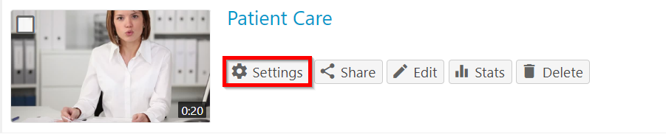

Click Manage and select Copy

The copied session will inherit the same permissions from the original folder.

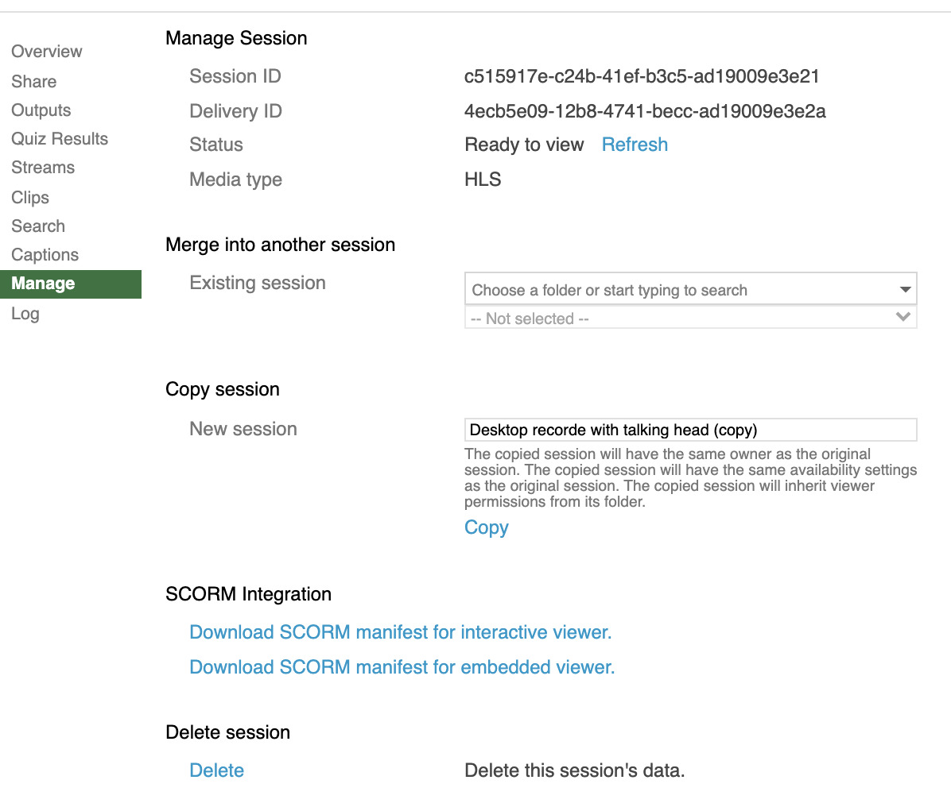

You will see the copy of the video in the Panopto folder with Copy added to the title.

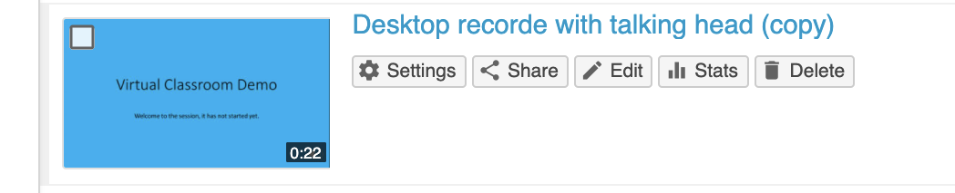

This copied video can be moved to another Panopto folder.

Move a Panopto video to another folder

Open the session Settings, and it will bring you to the Overview section.

You will see the video name and current folder, with an option to edit them.

Click Edit under the folder location and from the drop down of folders, select the desired folder destination for the session to be moved to.

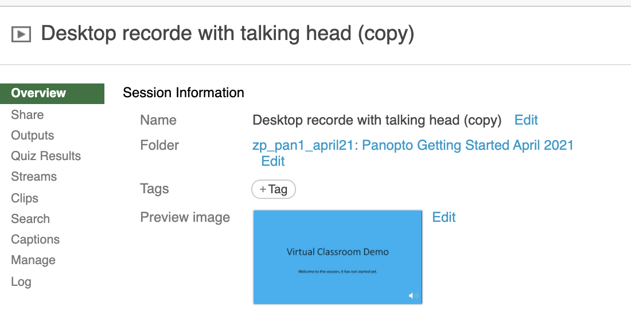

Click on Save to save the new folder location

